Integrating the Healthcare Enterprise



IHE Patient Care Coordination (PCC)
Technical Framework Supplement

Cross Enterprise TeleHomeMonitoring Workflow Definition Profile
(XTHM-WD)

Public Comment

Date: 16/05/12
Author: Valentina Ferrarini, Arianna Cocchiglia, Mauro Zanardini
Email: vferrarini@consorzioarsenal.it, acocchiglia@consorzioarsenal.it, mzanardini@consorzioarsenal.it,

Foreword
This page is standard language for all IHE supplements. The Introduction section following will list all other IHE documents that are modified by this supplement. This document is a supplement to the IHE Patient Care Coordination Technical Framework <VX.X>. The technical framework can be found at http://www.ihe.net/Technical_Framework/index.cfm#pcc.
This and all IHE supplements are written as changes to a base document. The base document is normally one or more IHE Final Text documents. Supplements tell a technical editor and the reader how to modify the final text (additions, deletions, changes in wording). In order to understand this supplement, the reader needs to read and understand all of the base documents that are modified by this supplement.
In this supplement you will see “boxed” instructions similar to the following:
Replace Section X.X by the following:
These “boxed” instructions are for the author to indicate to the Volume Editor how to integrate the relevant section(s) into the overall Technical Framework.
This format means the reader has to integrate the base documents and the supplement. When the material in the supplement is considered ready for incorporation into the final text of the Technical Framework, the IHE committees will update the technical framework documents with the final text. Supplements are written in this format to avoid duplication material. This means that two IHE documents (one possibly final text, and the other a supplement) should not contain contradictory material.
Text in this document is not considered final for the Technical Framework. It becomes Final Text only after the IHE Patient Care Coordination Technical Committee ballots the supplement (after testing) and agrees that the material is ready for integration with the existing Technical Framework documents.

It is submitted for <Trial Implementation/Public Comment> starting August XX, 20XX.
Comments on this supplement may be submitted http://forums.rsna.org:
- Select the “IHE” forum
- Select <Domain Name> Technical Framework
- Select <20XX-20XX> Supplements for Public Comment
- Select <Profile Name>

Please use the Public Comment Template provided there when starting your New Thread.

Details about IHE may be found at: www.ihe.net
Details about the IHE Patient Care Coordination may be found at: http://www.ihe.net/Domains/index.cfm
Details about the structure of IHE Technical Frameworks and Supplements may be found at: http://www.ihe.net/About/process.cfm and http://www.ihe.net/profiles/index.cfm
TABLE OF CONTENTS

Volume 1 – Profiles 7
Volume 2 – Content Modules 32

Introduction

This supplement is written for Trial Implementation. It is written as changes to the documents listed below. The reader should have already read and understood these documents:
- PCC Technical Framework Volume 1, Revision 5.0
- PCC Technical Framework Volume 2, Revision 5.0
This supplement also references other documents. The reader should have already read and understood these documents:
- IT Infrastructure Technical Framework Volume 1, Revision 6.0
- IT Infrastructure Technical Framework Volume 2, Revision 6.0
- IT Infrastructure Technical Framework Volume 3, Revision 6.0
- The Patient Identifier Cross-Reference (PIX) and Patient Demographic Query (PDQ) HL7 v3 Supplement to the IT Infrastructure Technical Framework.
- HL7 and other standards documents referenced in Volume 1 and Volume 2
- Dilbert 2.0: 20 Years of Dilbert by Scott Adams, ISBN-10: 0740777351, ISBN-13: 978-0740777356

Open Issues and Questions
- Reviewers should evaluate how to manage the task “Telemonitoring” in status FAILED. In general, the cardinality of this task is1..n but in the case where the status is FAILED, it should be required to be 2..n. After a “Telemonitoring” task is put in status FAILED (i.e. there are problems with sending data) there must be another “Telemonitoring” task with status COMPLETED (the measurement is repeated after the failure). Is there a need to specify this situation in the document? If yes, how can we describe it? (see table 6.1-1 page 32 of Volume 2)
- Reviewers should evaluate the need to define options within the Workflow Denition to facilitate implementation of the workflow definition profile. Should there be options on the (1) support of specific workflow tasks/status, (2) reference content document profiles, (3) remaining options from XDW ? These would be formalized and placed in Section X.4 of Volume 1. The requirements for the support of options related to the XDW Profile may not be properly placed in Section X.4 and may need to be moved to Volume 2.
- Reviewers should evaluate the proposed table in Section 6.5 that describes the documents created during the workflow process, their requirements, their nature and their related PCC (or other) document content profiles, if any, and the note that PCC may/should define them in the future. How specific should a workflow definition profile be in terms of referenced documents conformance requirements?
- In many parts of this document we present XML examples to better demonstrate how the Workflow Document can track information related to the process. This structure will be affected by CPs proposed to the ITI domain (CP-643, CP-637) so these examples may change: section 6.2.1.1 page 35, 6.2.2.1 page 37, 6.2.3.1 page 40, 6.2.4.1 page 41, 6.2.5.1 page 43, 6.2.6.1 page 46, 6.2.7.1 page 48, 6.2.8.1 page 50, 6.2.9.1 page 52 and Appendix A page 62.
Closed Issues
None

Volume 1 – Profiles

X Volume 1 - Cross Enterprise TeleHomeMonitoring Workflow Definition (XTHM-WD) Profile
This profile focuses on the definition of a standardized and shared document structure for the proper management of the clinical process involving chronic patients followed by telemonitoring services. Although this profile has the word “home” in its title, the telemonitoring process considered in this profile allows the patient to be monitored not only from his home but from the place in which he is resident.
The main goal is to allow every individual involved in the process (e.g. specialist, general practitioner, telemonitoring centre’s staff) to manage and share the complete clinical history of the patient, from the monitored data to the events occurring during the process (e.g. visits, changes of therapy). To achieve this, this profile is based on the Cross-enterprise Document Workflow (XDW) Profile that provides a structure to build cross-enterprise workflows, where each event and the related status and documents are tracked and shared between all individuals involved. The XTHM-WD Profile follows the technical specifications contained in the XDW Profile to define the rules needed to create and manage a cross-enterprise workflow related to a telemonitoring process.

X.1 Purpose and Scope
The workflow related to the management of patients with chronic diseases (e.g. heart failure, COPD, diabetes) followed by a telemonitoring service is a cross-enterprise workflow since many different individuals from different enterprises can be involved: specialists and physicians, working in hospitals, rural areas or urban areas, general practitioners (GP), and general caregivers, as well as the telemonitoring centre’s staff.
For the correct management of these patients, each of these individuals, managing his part of the telemonitoring workflow, should have also the possibility to share and manage the patient’s complete clinical history. However, at the moment there are no technical specifications allowing this to be done in a standardized manner.
This profile provides guidelines to define this kind of cross-enterprise workflow using the XDW profile, allowing every individual involved in a patient's care to share the complete telemonitoring workflow, including all related documents produced for each event occurring during the process (data sending, request for a visit, change of therapy), and the related workflow status.
This proposal focuses on the Cross Enterprise TeleHomeMonitoring Workflow Definition in support of telemonitoring workflow document and status management.
The key elements are:
- managing telemonitoring cross-enterprise workflow, tracking all events and related documents;
- managing workflow specific status with relationship to one or more documents;
- tracking status of all events in telemonitoring process (in progress, completed, etc.).

To demonstrate the scale of the problem, an analysis has been performed on some European data about the most relevant chronic diseases: now COPD affects approximately 44 million people; heart failure affects about 15 million people. The introduction of a telemonitoring service for these patients, with good workflow management, as defined in this profile, would entail a considerable advantage in terms of quality of life for patients and cost savings.

X.2 Process Flow
This section is focused on the description of the general telemonitoring process flow, which can be described with the following steps:
- The Telemonitoring process starts when a GP or a general caregiver requests the activation of a telemonitoring service for his patient to a telemonitoring service provider. In this initial phase of the process the GP defines the telemonitoring protocol for the patient and produces a telemonitoring Workflow Document with a “Requested” task as the first entry.
- The service provider now evaluates and approves the physician's request and activates the service; the workflow document is updated with a new “Approved Request” task.
- The patient starts to collect the required clinical parameters at his home or place of residence. The data collected is transmitted to the service provider that manages the data, making them available to any clinicians involved in the process. The Workflow Document is updated with a “Telemonitoring” task.
- If the data sent by the patient goes outside the threshold levels defined in the protocol, the service provider alerts the referring physician and updates the Workflow Document with a “Consult Request” task.
- The physician analyses the patient's data and decides if the patient needs to change their therapy, to have a specialist visit, or if there is no need to perform any action. The Workflow Document is updated with a task that depends on the decision taken by the clinician:
E.1 “Analysis and Change Protocol”
E.2 “Analysis and Request Visit”
E.3 “Analysis and No Action”.
- Depending on the resulting task from step E, two options can result:
F.1 If the decision is to schedule a visit, an e Referral process is activated. When the eReferral workflow ends the clinician that performed the referral updates the Workflow Document with the task “Visit Result”.
F.2 If the result includes a need to change the protocol, the service provider receives the protocol from the clinician and activates it, updating the Workflow Document with the task “New Protocol Activation”.
The patient now continues with the telemonitoring service.
The workflow ends and is set to “Closed” when the patient doesn’t need to be monitored any more by the telemonitoring service. Each task can lead to the closing of the Workflow Document and this can be tracked by including a closure document in the outputs of the current task.
These steps can be tracked in nine different tasks throughout the workflow:
- Requested: tracks step A, performed by the patient’s clinician;
- Approved Request: tracks step B, performed by the telemonitoring service provider;
- Telemonitoring: tracks step C, performed by the telemonitoring service provider;
- Consult Request: tracks step D, performed by the telemonitoring service provider;
- Analysis and Request Visit: tracks step E1, performed by the patient’s clinician;
- Visit Result: tracks step F1, performed by the patient’s clinician;
- Analysis and Change Protocol: tracks step E2, performed by the patient’s clinician;
- New Protocol Activation: tracks step F2, performed by the telemonitoring service provider;
- Analysis and No Actions: tracks step E3, performed by the patient’s clinician.

Figure X.2-1 below shows the schematic modality of all tasks related to the process and the relationship between these.

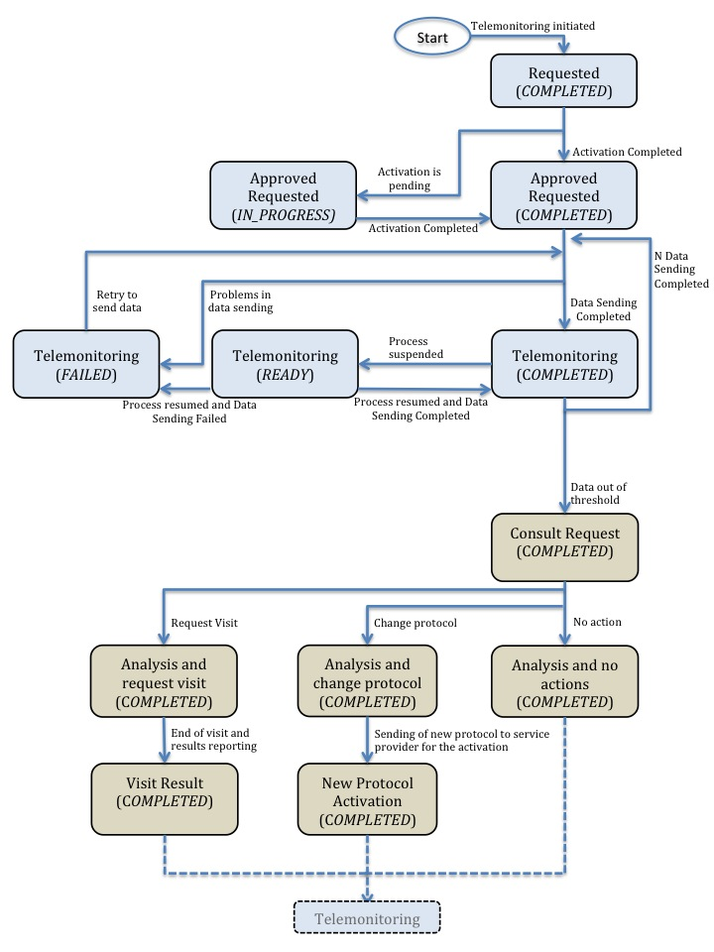
Figure X.2-1. Workflow Definition sample process flow
A telemonitoring process produces many documents and each of these documents are referenced in related tasks of the Workflow Document. Figure X.2-2 and Table X.2-1, outlines the documents needed as input and output for each task.
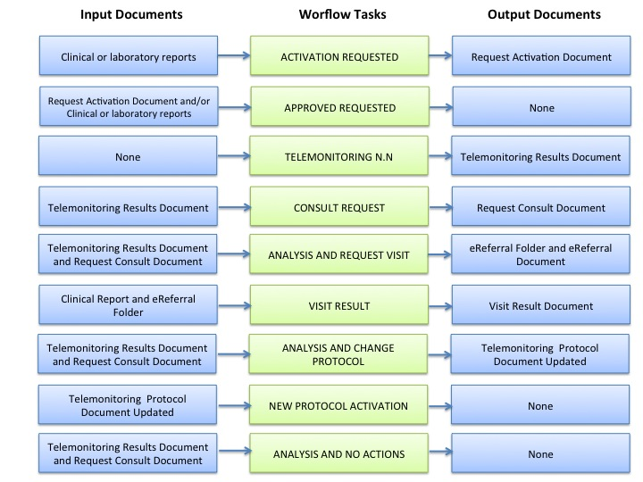
Figure X.2-2 – Input and Output Documents of each tasks

Task Type | Task Status | Input Docs | Option | Output Docs | Option
Requested | COMPLETED | Clinical or Laboratory Reports | O | Request Activation Document | R
Approved | IN_PROGRESS | Request Activation Document | R | N/A | -
Approved | IN_PROGRESS | Clinical or Laboratory Reports | O | N/A | -
Approved | COMPLETED | Request Activation Document | R | N/A | -
Approved | COMPLETED | Clinical or Laboratory Reports | O | N/A | -
Telemonitoring | COMPLETED | N/A | - | Telemonitoring Results Document | R
Telemonitoring | FAILED | N/A | - | Telemonitoring Results Document | R
Telemonitoring | READY | N/A | - | N/A | -
Consult Request | COMPLETED | Telemonitoring Results Document | R | Request Consult Document | R
Analysis and Request Visit | COMPLETED | Telemonitoring Results Document and Request Consult Document | R | eReferral folder.uniqueID and eReferral Document | R
Visit Result | COMPLETED | Clinical Report and eReferral folder.uniqueID | R | Visit Result Document | R
Analysis and Change Protocol | COMPLETED | Telemonitoring Results Document and Request Consult Document | R | Telemonitoring Protocol Updated | R
New Protocol Activation | COMPLETED | Telemonitoring Protocol Document Updated | R | N/A | -
Analysis and no actions | COMPLETED | Telemonitoring Results Document and Request Consult Document | R | N/A | -
Table X.2-1 – Input and Output Documents of each task/status pair

X.3 Workflow Actors
Many different systems can be involved in the telemonitoring process, but they all can generally be identified, based on their roles in the process, as one of three specific actors. Each of these workflow actors have specific rules associated with them in the process, which drive the process from one step to another, performing determinate actions on the workflow:
- Care Manager is the actor that performs the following actions and related tasks:
- Activating the telemonitoring service – task APPROVED;
- Creating the Telemonitoring Results Document for each set of data sent – task TELEMONITORING;
- Creating the Request Consult Document in the case of alarm situations – task REQUEST CONSULT;
- Activating new telemonitoring protocol when requested form the General Clinician Manager – Task NEW PROTOCOL ACTIVATION;
- General Clinician Manager is the actor that performs the following actions and related tasks:
- Creating the Workflow Document for the telemonitoring of his patient;
- Creating the Request Activation Document – task REQUESTED;
- Consult Manager is the actor that performs the following actions and related tasks:
- Analyzing any alarm situations and deciding how to manage them – tasks ANALYSIS AND REQUEST VISIT and ANALYSIS AND CHANGE PROTOCOL;
- If a specialist visit is needed, producing an eReferral Document and creating the related eReferral Workflow Document – task ANALYSIS AND REQUEST VISIT;
- After receive the Clinical Report by the specialist as the end of the eReferral process, checking the visit’s outcomes and confirming the telemonitoring protocol – task VISIT RESULT;
- If a change of protocol is decided, updating the Telemonitoring Protocol Document – task ANALYSIS AND CHANGE PROTOCOL;
- If no actions is decided, updating the Telemonitoring Protocol Document – task ANALYSIS AND NO ACTIONS.
Table X.3-1 describes these Workflow Actors.

Workflow  Actors | Description
Care Manager | Actor responsible for the management of the telemonitored data sent by the patient from his home and of the alarm situations incurring when data go outside of the thresholds
General Clinician Manager | Actor responsible for the telemonitoring process and producing the telemonitoring Workflow Document
Consult Manager | Actor responsible for the management of the clinical care process of the patient from the activation of the telemonitoring service to the clinical management of alarm situations reported by thCae Care Manager
Table X.3-1 – Workflow Actors
The figure below describes the relationship between each Workflow Actor and the tasks of the telemonitoring process.
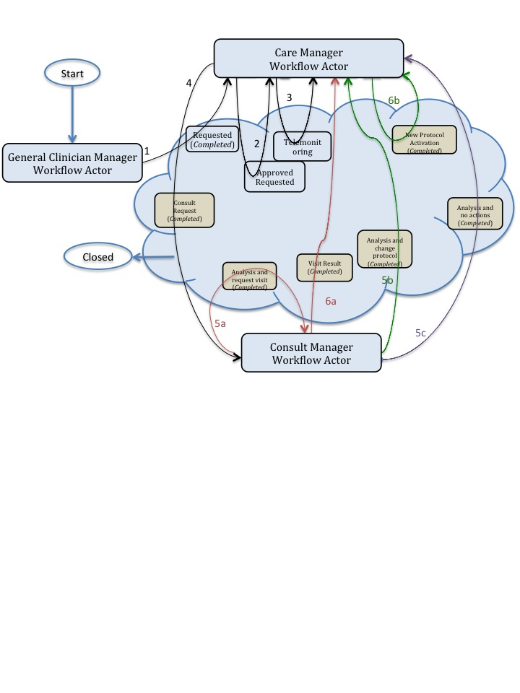
Figure X.3-1 – Workflow Actors and tasks

X.3.1 Use Cases
The use case presented in this section, related to the definition of a telemonitoring process workflow, is composed of two parts.
The first one is about the creation of the Workflow Document (WD), which tracks all the events occurring during the telemonitoring process of a patient, and how it is updated with the daily transmission of the patient's clinical data (from step A to C.1).
The second part of this use case follows the workflow that occurs when the data sent by the patient goes outside of the thresholds set in the protocol, causing the occurrence of an alarm situation for the patient (from step C.2 to step F).
The workflow related to this use case is a seven step process:
A. The GP requests the telemonitoring service for his chronic patient;
B. The telemonitoring service provider evaluates and accepts the activation request and activates the service for the patient;
C. The patient performs his measurements according to the protocol and transmits them to the telemonitoring service provider. At this point there are two possibilities:
C.1. The patients measurements are normal and telemonitoring continues;
C.2. The patients measurements are outside the thresholds defined;
D. The telemonitoring service provider detects an alarm situation for the patient and requests a physician’s consultation;
E. The GP analyses the alarm situation. At this point there are three possibilities:
E.1. The GP analyses the alarm situation and decides to request a specialist visit for his patient;
E.2. The GP analyses the alarm situation and decides to change the telemonitoring protocol of his patient, in particular the therapy or the monitoring timing or the alarm thresholds;
E.3. The GP analyses the alarm situation and decides to perform no actions.
F. The alarm situation is resolved. At this point there are three possibilities depending on the path chosen at step E:
F.1. The GP checks the results of the visit and confirm the new telemonitoring protocol.
F.2. The telemonitoring service provider activates the new telemonitoring protocol;

Each step is now described both from a clinical and a technical point of view.

We present below the detailed chronological sequence of steps.

A. The GP requests the telemonitoring service for his chronic patient
In this task, the GP determines that his patient with chronic heart failure needs to be followed by a telemonitoring service allowing him to be monitored remotely as he performs daily measurements of his clinical parameters. The GP requests a service activation to the telemonitoring service provider, creating a document for the formal request (Request Activation Document) including the customized telemonitoring protocol (clinical parameters to collect, frequency of data transmission, threshold values to detect alarm situations, information about the referencing physician and the patient’s therapy) and referencing the reports and results that can be used to evaluate the possibility of a follow up at home.
The GP’s software, or some system acting as a General Clinician Manager, produces the Request Activation Document and one Workflow Document to track the clinical workflow of the patient being followed by the telemonitoring service. As shown in column A of Figure X.3.1-2, at this time the Workflow Document has only one task (“Activation Requested”) characterized by:
- a status of “Completed”
- references to reports of clinical or laboratory exams as inputs of the task
- reference to the Request Activation Document as the output of the task
In order to share the documents produced during the task, the system acting as the General Clinician Manager submits the Request Activation Document and the Workflow Document to an XDS Document Repository as shown in box A of Figure 6.5-1.

B. The telemonitoring service provider evaluates and accepts the activation request and activates the service for the patient
In order to evaluate the activation request from the GP, the telemonitoring service provider queries for and retrieves the Request Activation Document and the associated Workflow Document using a system which acts as a Care Manager, as shown in box B of Figure 6.5-1.
If the telemonitoring service provider approves the activation request, as shown in column B of Figure X.3.1-2, it updates the Workflow Document with a new version in which a new task “Approved Request” has been added to the content of the previous version. The task “Approved Request” is characterized by:
- a status “Completed”
- the references to the Request Activation Document produced by the GP and the reports of clinical or laboratory exams as inputs of the task
The telemonitoring service provider's system, as a Care Manager, provides the updated version of Workflow Document to the XDS Document Repository/Registry, replacing the previous version.
At this step, there is the possibility for a system of subscription and notification, through the use of the Document Metadata Subscription (DSUB) profile or the Notification of Document Availability (NAV) profile, to notify the GP that performed the request that the patient has been activated.

C.1. The patient performs his measurements according to the protocol and transmits them to the telemonitoring service provider. The patients measurements are normal and telemonitoring continues
The patient is activated with the telemonitoring service. He collects his clinical parameters at home and sends these data to the telemonitoring service provider. The telemonitoring service provider evaluates the data received and includes them in the Telemonitoring Results Document referenced in the Workflow Document.
To accomplish this the telemonitoring service provider, using a system that acts as a Care Manager, queries and retrieves the Workflow Document and creates the Telemonitoring Results Document.
At this step of the workflow, as shown in column C.1 of Figure X.3.1-2, the Workflow Document is updated with a new version in which a new task “Telemonitoring n.1” is added to the content of the previous version of the Workflow Document. The task “Telemonitoring n.1” is characterized by:
- a status “Completed”
- a reference to the Telemonitoring Results Document as output of the task.
The telemonitoring service provider’s software, as a Care Manager, provides the updated version of Workflow Document to the Document Repository, replacing the previous version (see box C.1 in Figure 6.5-1).
At any time the GP may review the Workflow Document and the new documents produced related to this workflow. This is accomplished through a query and retrieve by the GP’s software of the active Workflow Document from the XDS Document Registry and the XDS Document Repository.
This process is repeated for every data transmission so the Workflow Document is continuously updated and tracks all events and their respective status along with the associated documents, allowing all physicians treating the patient to share and manage the complete workflow of the telemonitoring process any time they need.
Each time the patient performs a measurement this task is created, and there would be the possibility for a system of subscription and notification, through the use of the Document Metadata Subscription (DSUB) profile or the Notification of Document Availability (NAV) profile, to communicate the creation of the task and the related Telemonitoring Result Document to the GP, so that they can access the workflow and view the patient’s data.

Figure X.3.1-1 describes the process flow reporting the related tasks from step A to C.1.
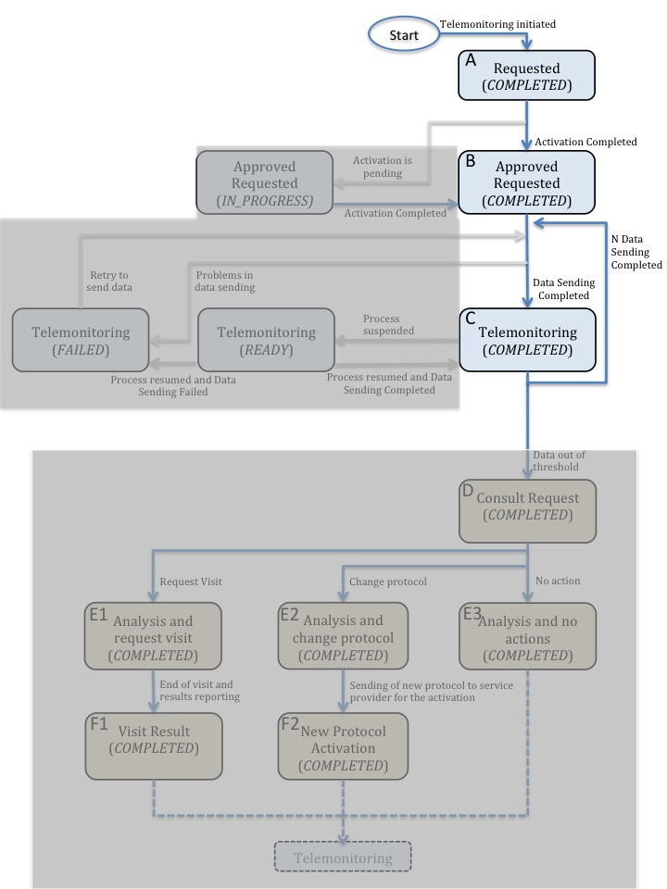
Figure X.3.1-1. Workflow Definition sample process flow

To demonstrate how the Workflow Document is populated during the process, Figure X.3.1-2 shows the evolution of the Workflow Document during this telemonitoring workflow from step A to step C.1. Each one of the steps is depicted in a column.

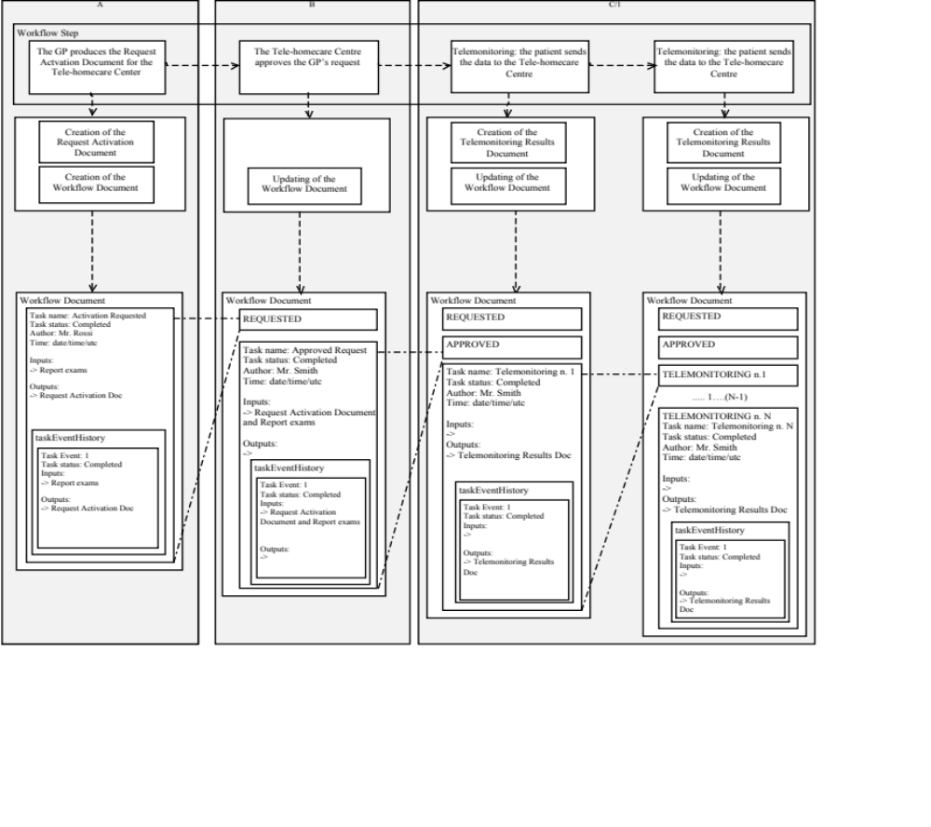Figure X.3.1-2. Management of the Workflow Document from step A to step C.1

C.2. The patient performs his measurements according to the protocol and transmits them to the telemonitoring service provider. The patients measurements are outside the thresholds defined;
The patient collects his clinical parameters at home and sends these data to the telemonitoring service provider. The telemonitoring service provider evaluates the data received and includes them in the Telemonitoring Results Document referenced in the Workflow Document.
To accomplish this the telemonitoring service provider uses a system that acts as Care Manager to query and retrieve the Workflow Document and creates the Telemonitoring Results Document.
At this step of the workflow, the Workflow Document is updated with a new version in which a new task “Telemonitoring n. n+1” is added to the content of the previous version of the Workflow Document. The task “Telemonitoring n. n+1” is characterized by:
- a status “Completed”
- the reference to the Telemonitoring Results Document as output of the task
The telemonitoring service provider’s system, as a Care Manager, provides the updated version of Workflow Document to the Document Repository, replacing the previous version.

D. The telemonitoring service provider detects the alarm situation for the patient and requires a physician’s consultation
If the data sent by the patient are outside of the normal range defined by the GP in the telemonitoring protocol, the telemonitoring service provider has to manage an alarm situation for the patient.
The telemonitoring service provider needs to alert the referring physician so, using a system that acts as a Care Manager, it creates a Request Consult Document including a request for the physician to evaluate this alarm situation. At the same time the telemonitoring service provider queries and retrieves the Workflow Document.
At this step of the workflow, the Workflow Document is updated with a new version in which a new task, “Consult Request,” is added to the content of the previous version. The task “Consult Request” is characterized by:
- a status “Completed”
- a reference to the Telemonitoring Results Document as input of the task
- a reference to the Request Consult Document as output of the task
The telemonitoring service provider’s software, as a Care Manager, provides the updated version of Workflow Document to the Document Repository, replacing the previous version.
Each time the telemonitoring service provider detects an alarm situation, there is a possibility for a system of subscription and notification, through the use of the Document Metadata Subscription (DSUB) profile or the Notification of Document Availability (NAV) profile, to communicate the presence of an alarm to the GP.

E. The GP analyses the alarm situation
The physician analyses the alarm situation for the patient by accessing the Workflow Document, using a system that acts as a Consult Manager, to query and retrieve it together with the Telemonitoring Results Document and the Request Consult Document.
Depending on how the GP decides to manage the alarm situation, there are three possible options at this point
For each of the following cases, when the GP solves the alarm situation, there is a possibility for a system of subscription and notification between tasks, through the use of the Document Metadata Subscription (DSUB) profile or the Notification of Document Availability (NAV) profile, to notify the telemonitoring service provider that the alarm condition has been resolved.

Case 1
E.1. The GP analyses the alarm situation and decides to request a specialist visit for his patient;

If the GP decides that the patient needs to have a specialist visit, he refers the patient to a specialist, creating an eReferral Document and the related eReferral Folder to track the specific events related to the visit, using a system that acts as a General Clinician Manager.
The Workflow Document is updated with a new task, “Analysis and Request Visit,” which is characterized by:
- a task status “Completed”
- references to the Telemonitoring Results Document and the Request Consult Document as inputs of the task
- references to the eReferral Document and the link to the eReferral Folder of the new Workflow Document as outputs
The GP’s system, as a Consult Manager, provides an updated version of the Workflow Document to the Document Repository, replacing the previous version.
At this time this Workflow will be on standby until the eReferral process is concluded. When the eReferral Workflow Document generated in this task is completed and the report produced by the specialist is returned to the GP, he can decide how to proceed.
For a description of the management of the eReferral Workflow Document, refer to the Cross-enterprise Basic eReferral Workflow Definition Profile.

F.1. The alarm situation is resolved. The GP checks the results of the visit and confirm the telemonitoring protocol.
The physician checks the results of the referral, consulting the Clinical Report referenced in the eReferral Workflow Document. At this time, the Workflow Document related to the telemonitoring process is reactivated by the GP, using a system that acts as a General Clinician Manager, to notify the telemonitoring service provider that the telemonitoring of the patient can proceed.
The GP creates a Visit Result Document including a description of the visits outcomes and a confirmation that the telemonitoring protocol can continue. This document is included in the Workflow Document as a reference.
The Workflow Document is updated with a new task, “Visit Result,” characterized by:
- a task status “Completed”
- references to the Clinical Report from the referral and a link to the eReferral Folder as inputs of the task
- a reference to the Visit Result Document as output of the task
The GP’s system, as a Consult Manager, provides the updated version of Workflow Document to the Document Repository, replacing the previous version.
The telemonitoring service provider can then review the Workflow Document and the new documents produced related to this workflow. This is accomplished through a query and retrieve of the active Workflow Document by the telemonitoring service provider’s system from the XDS Document Registry and the XDS Document Repository.
For more details about the evolution of the Workflow Document from step C.2 to step F.1 see Figure 6.3-1 in Volume 2 section 6.3. For more details about the transactions from step C.2 to step F.1 see Figure 6.3-4 in Volume 2 section 6.3.
Figure X.3.1-3 describes this process flow and related tasks from step A to F.1.
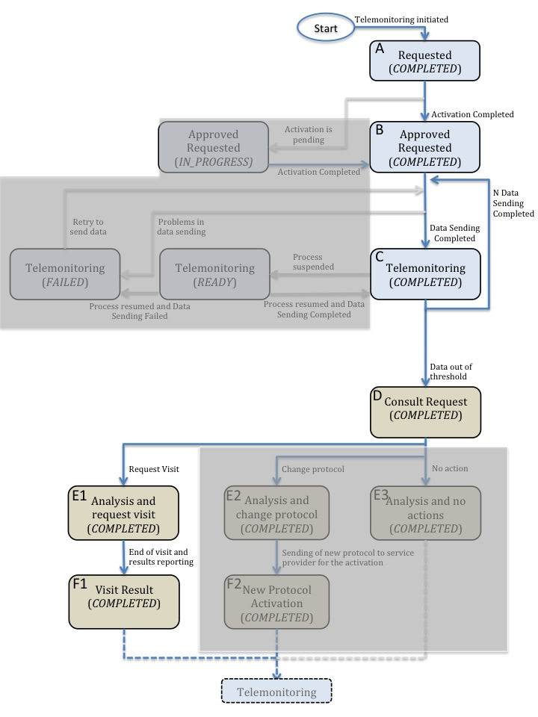
Figure X.3.1-3. Workflow Definition sample process flow

Case 2
E2. The GP analyses the alarm situation and decides to change the telemonitoring protocol of his patient, in particular the therapy or the monitoring timing or the alarm thresholds;
If the GP decides to change the telemonitoring protocol, including therapy type, telemonitoring timing or alarm thresholds:
- the GP’s system, as a Consult Manager, produces a Telemonitoring Protocol Document, updated with the new telemonitoring protocol
- the GP’s system updates the Workflow Document
This step is characterized by the creation of another task, “Analysis and Change Protocol,” related to the telemonitoring protocol change.
In the Workflow Document, the “Analysis and Change Protocol” task is characterized by:
- a task status “Completed”
- references to the Telemonitoring Results Document and the Request Consult Document as inputs of the task
- a reference to the Telemonitoring Protocol Document Updated as output of the task
The GP’s system, as a Consult Manager, provides the updated version of Workflow Document to the Document Repository, replacing the previous version.

F2. The alarm situation is resolved. The telemonitoring service provider activates the new telemonitoring protocol;
After the GP publishes the new telemonitoring protocol and notifies the telemonitoring service provider, the new telemonitoring protocol for the patient must be activated. The telemonitoring service provider retrieves the updated Telemonitoring Protocol Document and the associated Workflow Document accessing them using a system that acts as a Consult Manager.
Once the telemonitoring service provider activates the new telemonitoring protocol it updates the Workflow Document with a new version in which the task “New Protocol Activation” is updated with the new information. The task “New Protocol Activation” is characterized by:
- a status “Completed”
- the reference to the updated Telemonitoring Protocol Document produced by the GP as input of the task
The telemonitoring service provider’s system, as a Consult Manager, provides the updated version of Workflow Document to the XDS Document Repository/Registry, replacing the previous version.
Other clinicians involved in the care of the patient, e.g. the specialist that visits the patient, can access the Workflow Document to view his complete clinical history in relation to the telemonitoring process.
For more details about the evolution of the Workflow Document from step C.2 to step F.2 see Figure 6.3-2 in Volume 2, section 6.3. For more details about the transactions from step C.2 to step F.2 see Figure 6.3-5 in Volume 2, section 6.3.

Figure X.3.1-4 describes the process flow and related tasks from step A to F.2.
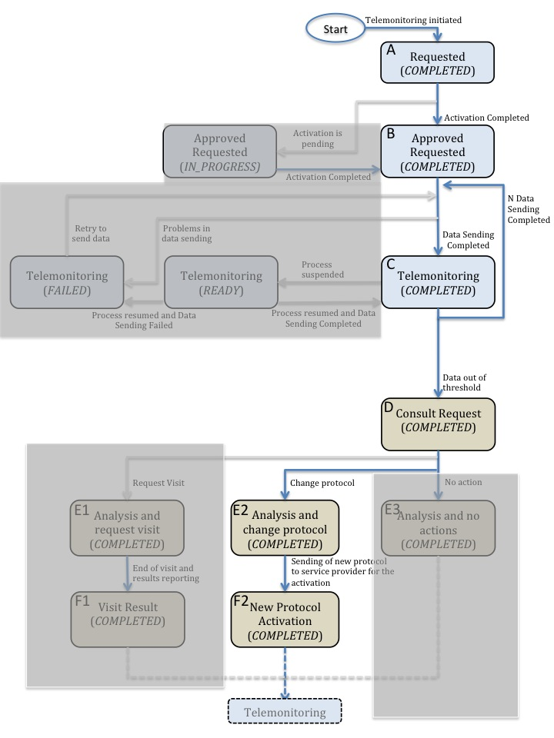
Figure X.3.1-4. Workflow Definition sample process flow

Case 3
E3. The GP analyses the alarm situation and decides to perform no actions.
If the GP that the alarm situation requires no action, he updates the Workflow document with a new task, “Analysis and No Actions”.
In the Workflow Document, the task “Analysis and No Actions” is characterized by:
- a task status “Completed”
- references to the Telemonitoring Results Document and the Request Consult Document as inputs of the task
The GP’s system, as a Consult Manager, provides the updated version of Workflow Document to the Document Repository, replacing the previous version.

For more details about the evolution of the Workflow Document from step C.2 to step E.3 see Figure 6.3-3 in Volume 2, section 6.3. For more details about the transactions from step C.2 to step F.3 see Figure 6.3-6 in Volume 2, section 6.3.

Figure X.3.1-5 describes the process flow and related tasks from step A to E.3.
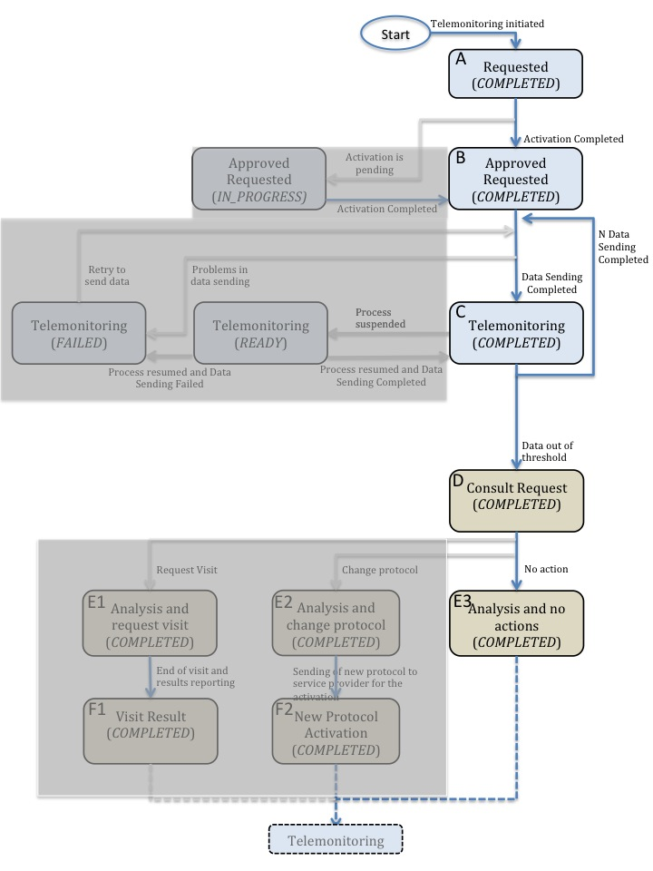
Figure X.3.1-5. Workflow Definition sample process flow

The workflow ends when the patient doesn’t need to be monitored any more by the telemonitoring service.
It would also be possible for a system of subscription and notification to communicate the progress between the different steps through the use of the Document Metadata Subscription (DSUB) profile or the Notification of Document Availability (NAV) profile.

X.4 Options
Options that may be selected for this Profile are listed in the ITI TF: table 30.2-1 along with the Actors to which they apply. These options aren’t required and the decision to apply them is left to the implementer.

Actor | XDW Options | Vol & Section
Care Manager | Required: XDW View Option | ITI TF-1: 30.2.1
Care Manager | Optional: XDW Document Import Option | ITI TF-1: 30.2.2
General Clinician Manager | Required: XDW View Option | ITI TF-1: 30.2.1
General Clinician Manager | Required: XDW Document Import Option | ITI TF-1: 30.2.2
Consult Manager | Optional: XDW View Option | ITI TF-1: 30.2.1
Consult Manager | Optional: XDW Document Import Option | ITI TF-1: 30.2.2
Table X.4-1 XTHM-WD Actors and Options

X.5 Groupings
The workflow definition actors introduced in this section represent a grouping of different XDW actors (for the specific on the XDW actor see in the section ITI TF-1: 30.1). In the table below which XDW actors are grouped by each XTHM-WD actors are presented.

Workflow Definition  Actor | Shall be grouped with XDW actors
Care Manager | XDW Content Consumer  XDW Content Updater
General Clinician Manager | XDW Content Creator  XDW Content Consumer
Consult Manager | XDW Content Consumer  XDW Content Updater
Table X.5-1 Workflow Actors grouping for sharing of referenced documents

Workflow Definition  Actor | Shall be grouped with the following actors
Care Manager | Content Profiles specific Document Creator Actors grouped with one of : XDS Document Source, XDR Document Source, XDM Media Creator  and  Content Profiles specific Document Consumer Actors grouped with one of : XDS Document Consumer, or XDR Document Recipient, or XDM Media Reader
General Clinician Manager | Content Profiles specific Document Creator Actors grouped with one of : XDS Document Source, XDR Document Source, XDM Media Creator  and  Content Profiles specific Document Consumer Actors grouped with one of : XDS Document Consumer, or XDR Document Recipient, or XDM Media Reader
Consult Manager | Content Profiles specific Document Creator Actors grouped with one of : XDS Document Source, XDR Document Source, XDM Media Creator  and  Content Profiles specific Document Consumer Actors grouped with one of : XDS Document Consumer, or XDR Document Recipient, or XDM Media Reader
Table X.5-2 Workflow Actors grouping for sharing of referenced documents

Volume 2 – Content Modules

5.1 XTHM Workflow Definition - XDW Workflow Document – Common Attributes

This workflow definition profile is assigned a specific OID, that shall be used to validate the workflowDefinitionReference element of a Workflow Document that tracks a telemonitoring process.

type of Workflow | Workflow Definition Reference
Telemonitoring workflow | 1.3.6.1.4.1.19376.1.5.3.1.5.2

Table 5.1-1 XTHM-WD Workflow – Workflow Definition Reference

The XTHM-WD Workflow Definition does not introduce new metadata and all the metadata elements used are the common XDS document metadata specified in ITI TF-3:4.1.5 and in ITI TF-3:5.4.6. In this section only the use of some specific metadata for use in the XTHM-WD context is specified.

XDS Metadata Attribute | Definition
typeCode | For the Workflow Document which tracks the XTHM-WD process the code for the typeCode shall be:  To be assigned by LOINC
classCode | For the Workflow Document which tracks the XTHM-WD process the code for the classCode is defined by the XDW profile.  See XDW Supplement Section YYYYYY.
eventCodeList | Rule 1:  An XTHM-WD workflow shall be created with code OPEN and shall remain in this status until it is set to CLOSE.  Rule 2:  An XTHM-WD workflow should be set to CLOSE when there is the need to end the telemonitoring workflow for any reason. In this case the current last task of the workflow has to be set in status COMPLETED. Each task of the process can lead to the closing of the workflow.  Rule 3:  An XTHM-WD workflow that was set to CLOSE can be reopened and set to OPEN if the patient has a need to use the telemonitoring service again.  See IHE ITI TF-3: 5.4.5.7 for a general description of this attribute.
serviceStartTime | Is the time at which work began on the first task for this workflow.
serviceStopTime | Is the time at which the status of the overall Workflow is changed from OPEN to CLOSED.  It shall be empty when the workflow is still in OPEN state.
Table 5.1-2 XTHM-WD Workflow – XDS Metadata Attribute

XDW Content Modules
Detailed knowledge of the Cross-enterprise Document Workflow (XDW) profile is indispensable in understanding the following sections.
For further technical details see the IHE ITI-TF.

Tasks Specifications

Workflow Description Overview

Task Type | Requirement  For task initiation | Task Statuses  *valid when task initiated | Task  Property | Input Docs | Option | Output Docs | Option
Requested | At XDW doc creation | COMPLETED* | Cardinality: 1..1  Removable: no | Clinical or Laboratory Reports | O | Request Activation Document | R
Approved | When Requested completed | IN_PROGRESS*  COMPLETED* | Cardinality: 1..1  Removable: no | Request Activation Document | R | N/A
 |  |  |  | Clinical or Laboratory Reports | O | N/A
Telemonitoring | For the first time in the WD: when Approved completed | READY  COMPLETED*  FAILED* | Cardinality: 1..n  Removable: no | N/A |  | Telemonitoring Result Document | R
Consult Request | If Telemonitoring with data out of the threshold | COMPLETED* | Cardinality: 1..n  Removable: no | Telemonitoring Results Document | R | Request Consult Document | R
Analysis and Request Visit | When Consult Request Completed | COMPLETED* | Cardinality: 1..n  Removable: no | Telemonitoring Results Document and Request Consult Document | R | eReferral folder.uniqueID and eReferral Document | R
Visit Result |  | COMPLETED* | Cardinality: 1..n  Removable: no | Clinical Report and eReferral folder.uniqueID | R | Visit Result Document | R
Analysis and Change Protocol | When Consult Request Completed | COMPLETED* | Cardinality: 1..n  Removable: no | Telemonitoring Results Document and Request Consult Document | R | Telemonitoring Protocol Updated | R
New Protocol Activation | When analysis and change protocol completed | COMPLETED* | Cardinality: 1..n  Removable: no | Telemonitoring Protocol Document Updated | R | N/A
Analysis and no actions | When Consult Request Completed | COMPLETED* | Cardinality: 1..n  Removable: no | Telemonitoring Results Document and Request Consult Document | R | N/A
Table 6.1-1 Workflow description overview

In this section we define rules and constraints for the creation of the XDW Workflow Document related to the telemonitoring process.
The set of rules defined here is necessary to manage transitions between tasks. For each task the following are defined:
- Task attributes: ID, name, type description;
- The sequence of the tasks: the previous and the next task;
- Who is allowed to create each task and to change the status;
- The task event;
- The input and output documents.

Task 1: Requested

Task attributes | Rules for the task “Requested”
Task id | Unique id of the instance of the task
Task type | Requested
Task name | Activation Requested
Task description | Request the activation of the telemonitoring service activation for a patient.
Task dependencies | Ancestors: None  Successors: Approved
Status allowed | COMPLETED
Status transactions (*) | None, task is created completed.
  Initial Status | Final Status | eventType
  none | COMPLETED | create
Input | - Optional  - All relevant documents useful to evaluate the possibility for follow up of the patient at home, e.g. clinical or laboratory reports
Output | - Required  - Request Activation Document
Owner | General Clinician Manager
owner changes | No
<taskEvent> | Only one
Task Removal allowed | May workflow participants remove a task when updating a XDW Workflow Document): No
Task duplication | May the task appear more than once in the Workflow Definition: No
(*) The element eventType stores the type of event that solicits the change in the task status. In this cell of the table above we want to associate the specific type of event to the status transaction solicited. (For further details on eventType element see XDW profile)

Encoding Example of XDW Task: Requested

<ns3:XDWTask>
<ns3:taskData>
<ns2:taskDetails>
<ns2:id>urn:oid:1.1.1.1.1</ns2:id>
<ns2:taskType>Requested</ns2:taskType>
<ns2:name>Activation Requested</ns2:name>
<ns2:status>COMPLETED</ns2:status>
<ns2:createdTime>2011-01-01T18:13:51.0Z</ns2:createdTime>
<ns2:lastModifiedTime>2011-01-01T18:13:51.0Z</ns2:lastModifiedTime>
<ns2:renderingMethodExists>false</ns2:renderingMethodExists>
<ns2:actualOwner>Mr. Rossi</ns2:actualOwner>
<ns2:createdBy>Mr. Rossi</ns2createdBy>
</ns2:taskDetails>
<ns2:description>Request for activation of a telehealth service</ns2:description>
<ns2:input>
<ns2:part name=”Laboratory Report”>
<reference uid=”urn:oid:1.2.3.4.1” home=”urn:oid:1.2.3”/>
</ns2:part>
</ns2:input>
<ns2:output>
<ns2:part name=”Request Activation Document”>
<reference uid=”urn:oid:1.2.3.4.2” home=”urn:oid:1.2.3”/>
</ns2:part>
</ns2:output>
</ns3:taskData>
<ns3:taskEventHistory>
<ns3:taskEvent>
<ns3:id>1</ns3:id>
<ns3:eventTime>2006-05-04T18:13:51.0Z</ns3:eventTime>
<ns3:identifier>urn:oid:1.1.1.1.1</ns3:identifier>
<ns3:eventType>create</ns3:eventType>
<ns3:status>COMPLETED</ns3:status>
</ns3:taskEvent>
</ns3:taskEventHistory>
</ns3:XDWTask>

Task 2: Approved

Task attributes | Rules for the task “Approved”
Task id | Unique id of the instance of the task
Task type | Approved
Task name | Approved Request
Task description | Approval of the request for activation for the telemonitoring service.
Task dependencies | Ancestors: Requested  Successors: Telemonitoring
Status allowed | IN_PROGRESS: if the enrollment of the patient is pending and needs more information or time to be completed  COMPLETED: if the enrollment is completed
Status transactions | None, if the task is created in completed state. If the task is created with status IN_PROGRESS, the status shall be changed to COMPLETED when the approving process is completed
  Initial Status | Final Status | eventType
  none | IN_PROGRESS | create
  IN_PROGRESS | COMPLETED | complete
  none | COMPLETED | create
Input | - Required  - Request activation Document  - Optional  - Report of clinical or laboratory exam
Output | None
Owner | Care Manager (Approver of the request activation)
owner changes | No
<taskEvent> | Only one (completed): if the approving process is completed  Two in the other cases
Task Removal allowed | May workflow participants remove a task when updating a XDW Workflow Document): No
Task duplication | May the task appear more than once in the Workflow Definition: No

Encoding Example of XDW Task: Approved

<ns3:XDWTask>
<ns3:taskData>
<ns2:taskDetails>
<ns2:id>urn:oid:1.1.1.1.1</ns2:id>
<ns2:taskType>Approved</ns2:taskType>
<ns2:name>Approved Request</ns2:name>
<ns2:status>COMPLETED</ns2:status>
<ns2:createdTime>2011-01-02T10:10:51.0Z</ns2:createdTime>
<ns2:lastModifiedTime>2011-01-02T10:10:51.0Z</ns2:lastModifiedTime>
<ns2:renderingMethodExists>false</ns2:renderingMethodExists>
<ns2:actualOwner>Mr. Smith</ns2:actualOwner>
<ns2:createdBy>Mr. Smith</ns2createdBy>
</ns2:taskDetails>
<ns2:description>Request for activation of a telehealth service</ns2:description>
<ns2:input>
<ns2:part name=”Request Activation Document”>
<reference uid=”urn:oid:1.2.3.4.2” home=”urn:oid:1.2.3”/>
</ns2:part>
</ns2:input>
</ns3:taskData>
<ns3:taskEventHistory>
<ns3:taskEvent>
<ns3:id>1</ns3:id>
<ns3:eventTime>2011-01-02T10:10:51.0Z</ns3:eventTime>
<ns3:identifier>urn:oid:1.1.1.1.1</ns3:identifier>
<ns3:eventType>create</ns3:eventType>
<ns3:status>COMPLETED</ns3:status>
</ns3:taskEvent>
</ns3:taskEventHistory>
</ns3:XDWTask>

Task 3: Telemonitoring

Task attributes | Rules for the task “Telemonitoring”
Task id | Unique id of the instance of the task
Task type | Telemonitoring
Task name | Telemonitoring <N>
Task description | Sending of data to the service provider
Task dependencies | Ancestors: Approved, Telemonitoring, Visit Result, New Protocol Activation.  Successors: Telemonitoring, Consult Request
Status allowed | READY: if the process is suspended for a period  or  COMPLETED  or  FAILED: in case of problems in sending data. In this case it’s necessary to repeat the failed step.
Status transactions | None if the task created with status COMPLETED or FAILED. If there is the need to suspend the telemonitoring for a patient, the last task available with status COMPLETED moves to the status READY. When the process is resumed, the status shall be changed to COMPLETED, or to FAILED if there are problems in sending data when the process is resumed.
  Initial Status | Final Status | eventType
  none | COMPLETED | create
  COMPLETED | READY | suspend
  READY | COMPLETED | resume
  READY | FAILED | fail
  none | FAILED | fail
Input | None
Output | - Required  - Telemonitoring Results Document
Owner | Care Manager
owner changes | No
<taskEvent> | Only one (completed)  Only one (failed): if there are problems in sending data  Two in the other cases
Task Removal allowed | May workflow participants remove a task when updating a XDW Workflow Document): No
Task duplication | May the task appear more than once in the Workflow Definition: Yes

Encoding Example of XDW Task: Telemonitoring

<ns3:XDWTask>
<ns3:taskData>
<ns2:taskDetails>
<ns2:id>urn:oid:1.1.1.1.1</ns2:id>
<ns2:taskType>Telemonitoring</ns2:taskType>
<ns2:name>Telemonitoring 1</ns2:name>
<ns2:status>COMPLETED</ns2:status>
<ns2:createdTime>2011-01-03T13:01:50.0Z</ns2:createdTime>
<ns2:lastModifiedTime>2011-01-03T13:01:50.0Z</ns2:lastModifiedTime>
<ns2:renderingMethodExists>false</ns2:renderingMethodExists>
<ns2:actualOwner>Mr. Smith</ns2:actualOwner>
<ns2:createdBy>Mr. Smith</ns2createdBy>
</ns2:taskDetails>
<ns2:description>Sending of data to the service provider</ns2:description>
<ns2:output>
<ns2:part name=”Telemonitoring Result Document”>
<reference uid=”urn:oid:1.2.3.4.2” home=”urn:oid:1.2.3”/>
</ns2:part>
</ns2:output>
</ns3:taskData>
<ns3:taskEventHistory>
<ns3:taskEvent>
<ns3:id>1</ns3:id>
<ns3:eventTime>2011-01-32T13:01:50.0Z</ns3:eventTime>
<ns3:identifier>urn:oid:1.1.1.1.1</ns3:identifier>
<ns3:eventType>create</ns3:eventType>
<ns3:status>COMPLETED</ns3:status>
</ns3:taskEvent>
</ns3:taskEventHistory>
</ns3:XDWTask>

Task 4: Consult Request

Task attributes | Rules for the task “Consult Request”
Task id | Unique id of the instance of the task
Task type | Consult Request
Task name | Consult Request <N>
Task description | Generation of an alarm because data are outside of the thresholds
Task dependencies | Ancestors: Telemonitoring with data out of the threshold  Successors: Analysis and Request visit, Analysis and change protocol, Analysis and no actions
Status allowed | COMPLETED
Status transactions | None, task is created with status completed.
  Initial Status | Final Status | eventType
  none | COMPLETED | create
Input | - Required  - Telemonitoring Results Document
Output | - Required  - Request Consult Document
Owner | Care Manager
owner changes | No
<taskEvent> | Only one
Task Removal allowed | May workflow participants remove a task when updating a XDW Workflow Document): No
Task duplication | May the task appear more than once in the Workflow Definition: Yes

Encoding Example of XDW Task: Consult Request

<ns3:XDWTask>
<ns3:taskData>
<ns2:taskDetails>
<ns2:id>urn:oid:1.1.1.1.1</ns2:id>
<ns2:taskType>Consult Request</ns2:taskType>
<ns2:name>Consult Request</ns2:name>
<ns2:status>COMPLETED</ns2:status>
<ns2:createdTime>2011-01-04T13:11:05.0Z</ns2:createdTime>
<ns2:lastModifiedTime>2011-01-04T13:11:05.0Z</ns2:lastModifiedTime>
<ns2:renderingMethodExists>false</ns2:renderingMethodExists>
<ns2:actualOwner>Mr. Smith</ns2:actualOwner>
<ns2:createdBy>Mr. Smith</ns2createdBy>
</ns2:taskDetails>
<ns2:description>Generation of an alarm because data are out of the thershold </ns2:description>
<ns2:input>
<ns2:part name=”Telemonitoring Result Document”>
<reference uid=”urn:oid:1.2.3.4.2” home=”urn:oid:1.2.3”/>
</ns2:part>
</ns2:input>
<ns2:output>
<ns2:part name=”Request Consult Document”>
<reference uid=”urn:oid:1.2.3.4.2” home=”urn:oid:1.2.3”/>
</ns2:part>
</ns2:output>
</ns3:taskData>
<ns3:taskEventHistory>
<ns3:taskEvent>
<ns3:id>1</ns3:id>
<ns3:eventTime>2011-01-04T13:11:05.0Z</ns3:eventTime>
<ns3:identifier>urn:oid:1.1.1.1.1</ns3:identifier>
<ns3:eventType>create</ns3:eventType>
<ns3:status>COMPLETED</ns3:status>
</ns3:taskEvent>
</ns3:taskEventHistory>
</ns3:XDWTask>

Task 5: Analysis and Request Visit

Task attributes | Rules for the task “Analysis and Request Visit”
Task id | Unique id of the instance of the task
Task type | Analysis and Request Visit
Task name | Analysis and Request Visit <N>
Task description | Analysis of the Telemonitoring Results Document and request of a specialistic consultation
Task dependencies | Ancestors: Consult Request  Successors: Visit Result
Status allowed | COMPLETED
Status transactions | None, task is created with status completed.
  Initial Status | Final Status | eventType
  none | COMPLETED | create
Input | - Required  - Telemonitoring Results Document  - Request Consult Document
Output | - Required  - eReferral folder.uniqueID  - eReferral document
Owner | Consult Manager
owner changes | No
<taskEvent> | Only one
Task Removal allowed | May workflow participants remove a task when updating a XDW Workflow Document): No
Task duplication | May the task appear more than once in the Workflow Definition: Yes

Encoding Example of XDW Task: Anaysis and Request Visit

<ns3:XDWTask>
<ns3:taskData>
<ns2:taskDetails>
<ns2:id>urn:oid:1.1.1.1.1</ns2:id>
<ns2:taskType>Analysis and Request Visit</ns2:taskType>
<ns2:name>Analysis and Request Visit</ns2:name>
<ns2:status>COMPLETED</ns2:status>
<ns2:createdTime>2011-01-04T18:13:05.0Z</ns2:createdTime>
<ns2:lastModifiedTime>2011-01-04T18:13:05.0Z</ns2:lastModifiedTime>
<ns2:renderingMethodExists>false</ns2:renderingMethodExists>
<ns2:actualOwner>Mr. Rossi</ns2:actualOwner>
<ns2:createdBy>Mr. Rossi</ns2createdBy>
</ns2:taskDetails>
<ns2:description>Analysis of the Telemonitoring Results Document and request of a specialistic consultation</ns2:description>
<ns2:input>
<ns2:part name=”Telemonitoring Result Document”>
<reference uid=”urn:oid:1.2.3.4.2” home=”urn:oid:1.2.3”/>
</ns2:part>
<ns2:part name=”Request Consult Document”>
<reference uid=”urn:oid:1.2.3.4.2” home=”urn:oid:1.2.3”/>
</ns2:part>
</ns2:input>
<ns2:output>
<ns2:part name=”eReferral Document”>
<reference uid=”urn:oid:1.2.3.4.2” home=”urn:oid:1.2.3”/>
</ns2:part>
<ns2:part name=”XDSFolder.uniqueId”>
<reference uid=”urn:oid:1.2.3.4.2” home=”urn:oid:1.2.3”/>
</ns2:part>
</ns2:output>
</ns3:taskData>
<ns3:taskEventHistory>
<ns3:taskEvent>
<ns3:id>1</ns3:id>
<ns3:eventTime>2011-01-04T18:13:05.0Z</ns3:eventTime>
<ns3:identifier>urn:oid:1.1.1.1.1</ns3:identifier>
<ns3:eventType>create</ns3:eventType>
<ns3:status>COMPLETED</ns3:status>
</ns3:taskEvent>
</ns3:taskEventHistory>
</ns3:XDWTask>

Task 6: Visit Result

Task attributes | Rules for the task “Visit Result”
Task id | Unique id of the instance of the task
Task type | Visit Result
Task name | Visit Result <N>
Task description | Analysis of the Results of the requested eReferral process
Task dependencies | Ancestors: Analysis and Request Visit  Successors:  - Telemonitoring: If the telemonitoring can continue.  - Analysis and Change Protocol: If the General Clinician Manager deems that the result of the visit requires a change of the telemonitoring protocol  - Analysis and Request Visit: If another visit is needed
Status allowed | COMPLETED
Status transactions | None, task is created with status completed.
  Initial Status | Final Status | eventType
  none | COMPLETED | create
Input | - Required  - Clinical Report  - eReferral folder.uniqueID
Output | - Required  - Visit Result Document
Owner | Consult Manager
owner changes | No
<taskEvent> | Only one
Task Removal allowed | May workflow participants remove a task when updating a XDW Workflow Document): No
Task duplication | May the task appear more than once in the Workflow Definition: Yes

Encoding Example of XDW Task: Visit Result

<ns3:XDWTask>
<ns3:taskData>
<ns2:taskDetails>
<ns2:id>urn:oid:1.1.1.1.1</ns2:id>
<ns2:taskType>Visit Result</ns2:taskType>
<ns2:name>Visit Result</ns2:name>
<ns2:status>COMPLETED</ns2:status>
<ns2:createdTime>2011-02-01T09:11:25.0Z</ns2:createdTime>
<ns2:lastModifiedTime>2011-02-01T09:11:25.0Z</ns2:lastModifiedTime>
<ns2:renderingMethodExists>false</ns2:renderingMethodExists>
<ns2:actualOwner>Mr. Rossi</ns2:actualOwner>
<ns2:createdBy>Mr. Rossi</ns2createdBy>
</ns2:taskDetails>
<ns2:description>Analysis of the Results of the eReferral process requested </ns2:description>
<ns2:input>
<ns2:part name=”Clinical Report”>
<reference uid=”urn:oid:1.2.3.4.2” home=”urn:oid:1.2.3”/>
</ns2:part>
<ns2:part name=”XDSFolder.uniqueId”>
<reference uid=”urn:oid:1.2.3.4.2” home=”urn:oid:1.2.3”/>
</ns2:part>
</ns2:input>
<ns2:output>
<ns2:part name=”Visit Result Document”>
<reference uid=”urn:oid:1.2.3.4.2” home=”urn:oid:1.2.3”/>
</ns2:part>
</ns2:output>
</ns3:taskData>
<ns3:taskEventHistory>
<ns3:taskEvent>
<ns3:id>1</ns3:id>
<ns3:eventTime>2011-02-01T09:11:25.0Z</ns3:eventTime>
<ns3:identifier>urn:oid:1.1.1.1.1</ns3:identifier>
<ns3:eventType>create</ns3:eventType>
<ns3:status>COMPLETED</ns3:status>
</ns3:taskEvent>
</ns3:taskEventHistory>
</ns3:XDWTask>

Task 7: Analysis and Change Protocol

Task attributes | Rules for the task “Analysis and Change Protocol”
Task id | Unique id of the instance of the task
Task type | Analysis and Change Protocol
Task name | Analysis and Change Protocol <N>
Task description | Analysis of the Telemonitoring Results Document and change of the telemonitoring protocol
Task dependencies | Ancestors: Consult Request  Successors: New Protocol Activation
Status allowed | COMPLETED
Status transactions | None, task is created with status completed.
  Initial Status | Final Status | eventType
  none | COMPLETED | create
Input | - Required  - Telemonitoring Results Document  - Request Consult Document
Output | - Required  - Telemonitoring Protocol Updated
Owner | Consult Manager
owner changes | No
<taskEvent> | Only one
Task Removal allowed | May workflow participants remove a task when updating a XDW Workflow Document): No
Task duplication | May the task appear more than once in the Workflow Definition: Yes

Encoding Example of XDW Task: Anaysis and Change Protocol

<ns3:XDWTask>
<ns3:taskData>
<ns2:taskDetails>
<ns2:id>urn:oid:1.1.1.1.1</ns2:id>
<ns2:taskType>Analysis and Change Protocol</ns2:taskType>
<ns2:name>Analysis and Change Protocol</ns2:name>
<ns2:status>COMPLETED</ns2:status>
<ns2:createdTime>2011-02-01T09:11:25.0Z</ns2:createdTime>
<ns2:lastModifiedTime>2011-02-01T09:11:25.0Z</ns2:lastModifiedTime>
<ns2:renderingMethodExists>false</ns2:renderingMethodExists>
<ns2:actualOwner>Mr. Rossi</ns2:actualOwner>
<ns2:createdBy>Mr. Rossi</ns2createdBy>
</ns2:taskDetails>
<ns2:description>Analysis of the Telemonitoring Results Document and change of the telemonitoring protocol</ns2:description>
<ns2:input>
<ns2:part name=”Telemonitoring Result Document”>
<reference uid=”urn:oid:1.2.3.4.2” home=”urn:oid:1.2.3”/>
</ns2:part>
<ns2:part name=”Request Consult Document”>
<reference uid=”urn:oid:1.2.3.4.2” home=”urn:oid:1.2.3”/>
</ns2:part>
</ns2:input>
<ns2:output>
<ns2:part name=”Telemonitoring Protocol Updated”>
<reference uid=”urn:oid:1.2.3.4.2” home=”urn:oid:1.2.3”/>
</ns2:part>
</ns2:output>
</ns3:taskData>
<ns3:taskEventHistory>
<ns3:taskEvent>
<ns3:id>1</ns3:id>
<ns3:eventTime>2011-02-01T09:11:25.0Z</ns3:eventTime>
<ns3:identifier>urn:oid:1.1.1.1.1</ns3:identifier>
<ns3:eventType>create</ns3:eventType>
<ns3:status>COMPLETED</ns3:status>
</ns3:taskEvent>
</ns3:taskEventHistory>
</ns3:XDWTask>

Task 8: New Protocol Activation

Task attributes | Rules for the task “New Protocol Activation”
Task id | Unique id of the instance of the task
Task type | New Protocol Activation
Task name | New Protocol Activation <N>
Task description | Analysis of the Telemonitoring Protocol Updated and new protocol activation
Task dependencies | Ancestors: New Protocol Activation  Successors: Telemonitoring
Status allowed | COMPLETED
Status transactions | None, task is created in status completed.
  Initial Status | Final Status | eventType
  none | COMPLETED | create
Input | - Required  - Telemonitoring Protocol Document Updated
Output | None
Owner | Care Manager
owner changes | No
<taskEvent> | Only one
Task Removal allowed | May workflow participants remove a task when updating a XDW Workflow Document): No
Task duplication | May the task appear more than once in the Workflow Definition: Yes

Encoding Example of XDW Task: New Protocol Activation

<ns3:XDWTask>
<ns3:taskData>
<ns2:taskDetails>
<ns2:id>urn:oid:1.1.1.1.1</ns2:id>
<ns2:taskType>New Protocol Activation</ns2:taskType>
<ns2:name>New Protocol Activation</ns2:name>
<ns2:status>COMPLETED</ns2:status>
<ns2:createdTime>2011-02-02T09:11:25.0Z</ns2:createdTime>
<ns2:lastModifiedTime>2011-02-02T09:11:25.0Z</ns2:lastModifiedTime>
<ns2:renderingMethodExists>false</ns2:renderingMethodExists>
<ns2:actualOwner>Mr. Smith</ns2:actualOwner>
<ns2:createdBy>Mr. Smith</ns2createdBy>
</ns2:taskDetails>
<ns2:description>Analysis of the Telemonitoring Results Document and change of the telemonitoring protocol</ns2:description>
<ns2:input>
<ns2:part name=”Telemonitoring Protocol Updated”>
<reference uid=”urn:oid:1.2.3.4.2” home=”urn:oid:1.2.3”/>
</ns2:part>
</ns2:input>
</ns3:taskData>
<ns3:taskEventHistory>
<ns3:taskEvent>
<ns3:id>1</ns3:id>
<ns3:eventTime>2011-02-02T09:11:25.0Z</ns3:eventTime>
<ns3:identifier>urn:oid:1.1.1.1.1</ns3:identifier>
<ns3:eventType>create</ns3:eventType>
<ns3:status>COMPLETED</ns3:status>
</ns3:taskEvent>
</ns3:taskEventHistory>
</ns3:XDWTask>

Task 9: Analysis and no actions

Task attributes | Rules for the task “Analysis and no actions”
Task id | Unique id of the instance of the task
Task type | Analysis and no actions
Task name | Analysis and no actions <N>
Task description | Analysis of the Telemonitoring Results Document and no actions are necessary
Task dependencies | Ancestors: Consult Request  Successors: Telemonitoring
Status allowed | COMPLETED
Status transactions | None, task is created in status completed.
  Initial Status | Final Status | eventType
  none | COMPLETED | create
Input | - Required  - Telemonitoring Results Document  - Request Consult Document
Output | None
Owner | Consult Manager
owner changes | No
<taskEvent> | Only one
Task Removal allowed | May workflow participants remove a task when updating a XDW Workflow Document): No
Task duplication | May the task appear more than once in the Workflow Definition: Yes

Encoding Example of XDW Task: Anaysis and no actions

<ns3:XDWTask>
<ns3:taskData>
<ns2:taskDetails>
<ns2:id>urn:oid:1.1.1.1.1</ns2:id>
<ns2:taskType>Analysis and no Actions</ns2:taskType>
<ns2:name> Analysis and no Actions</ns2:name>
<ns2:status>COMPLETED</ns2:status>
<ns2:createdTime>2011-02-01T09:11:25.0Z</ns2:createdTime>
<ns2:lastModifiedTime>2011-02-01T09:11:25.0Z</ns2:lastModifiedTime>
<ns2:renderingMethodExists>false</ns2:renderingMethodExists>
<ns2:actualOwner>Mr. Rossi</ns2:actualOwner>
<ns2:createdBy>Mr. Rossi</ns2createdBy>
</ns2:taskDetails>
<ns2:description>Analysis of the Telemonitoring Results Document and no actions are necessary</ns2:description>
<ns2:input>
<ns2:part name=”Telemonitoring Result Document”>
<reference uid=”urn:oid:1.2.3.4.2” home=”urn:oid:1.2.3”/>
</ns2:part>
<ns2:part name=”Request Consult Document”>
<reference uid=”urn:oid:1.2.3.4.2” home=”urn:oid:1.2.3”/>
</ns2:part>
</ns2:input>
</ns3:taskData>
<ns3:taskEventHistory>
<ns3:taskEvent>
<ns3:id>1</ns3:id>
<ns3:eventTime>2011-02-01T09:11:25.0Z</ns3:eventTime>
<ns3:identifier>urn:oid:1.1.1.1.1</ns3:identifier>
<ns3:eventType>create</ns3:eventType>
<ns3:status>COMPLETED</ns3:status>
</ns3:taskEvent>
</ns3:taskEventHistory>
</ns3:XDWTask>

Workflow composition Diagrams and Transaction Flow in Support of the XTHM-WD Workflow

The following diagrams provide an informational depiction of the evolution of the Workflow Document during the telemonitoring process (Figure 6.3-1 – Figure 6.3-3) and of the combined use of the XTHM-WD Workflow Definition Profile along with the XDW Content Profile and the underlying XDS Intergation Profile (Figure 6.3-4 – Figure 6.3-6).
Figure 6.3-1 represents the evolution of the workflow document from the detection of an alarm situation to the decision to shedule a visit for the patient.
Figure 6.3-4 represents the sequence diagram from the beginning of the telemonitoring process to the decision to schedule a vist for the patient in case of alarm situation.

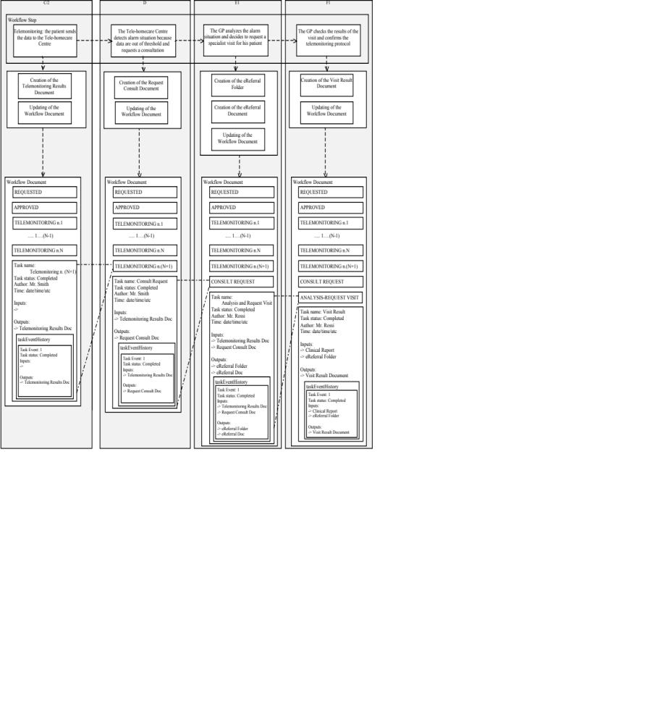Figure 6.3-1. Management of the Workflow Document from step C/2 to step F1

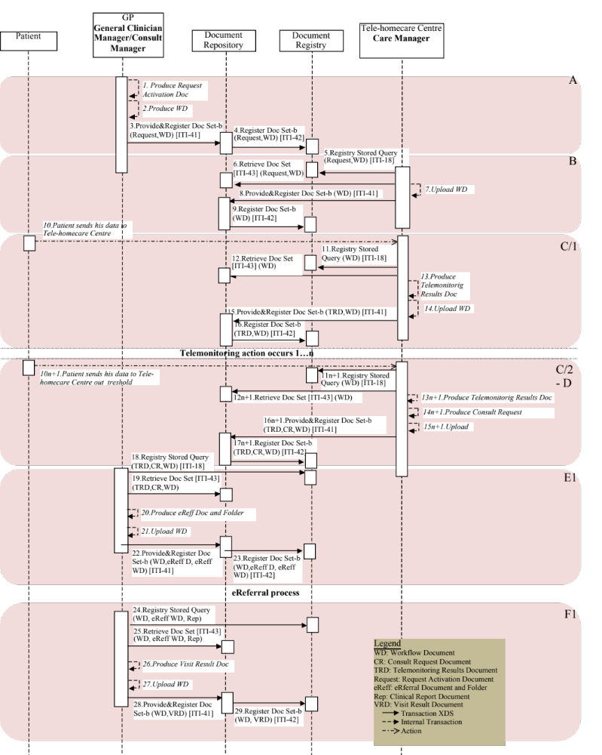
Figure 6.3-4. Basic Process Flow in Cross Enterprise TeleHomeMonitoring Workflow Definition Profile from steps A to F1
Figure 6.3-2 represents the evolution of the workflow document from the detection of an alarm situation to the decision to change the telemonitoring protocol and its activation.
Figure 6.3-5 represent the sequence diagram from the beginning of the telemonitoring process to the decision to change the telemonitoring protocol in case of alarm situation and its activation.

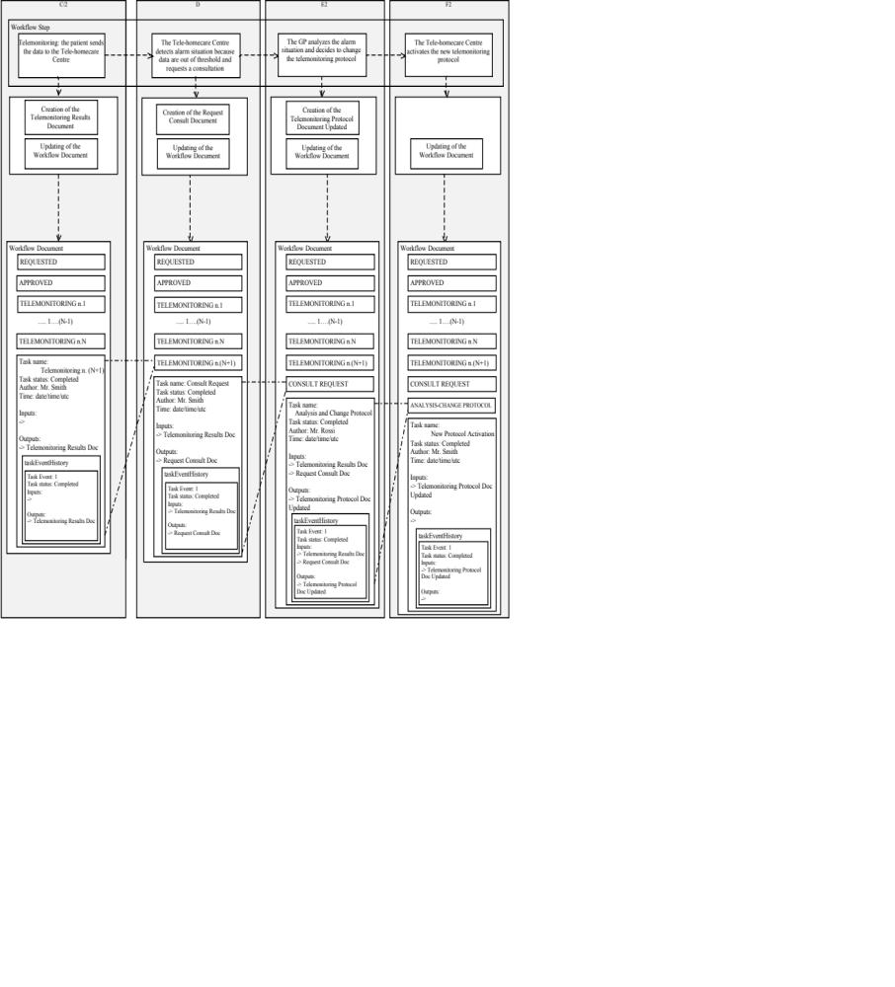
Figure 6.3-2. Management of the Workflow Document from step C/2 to step F2

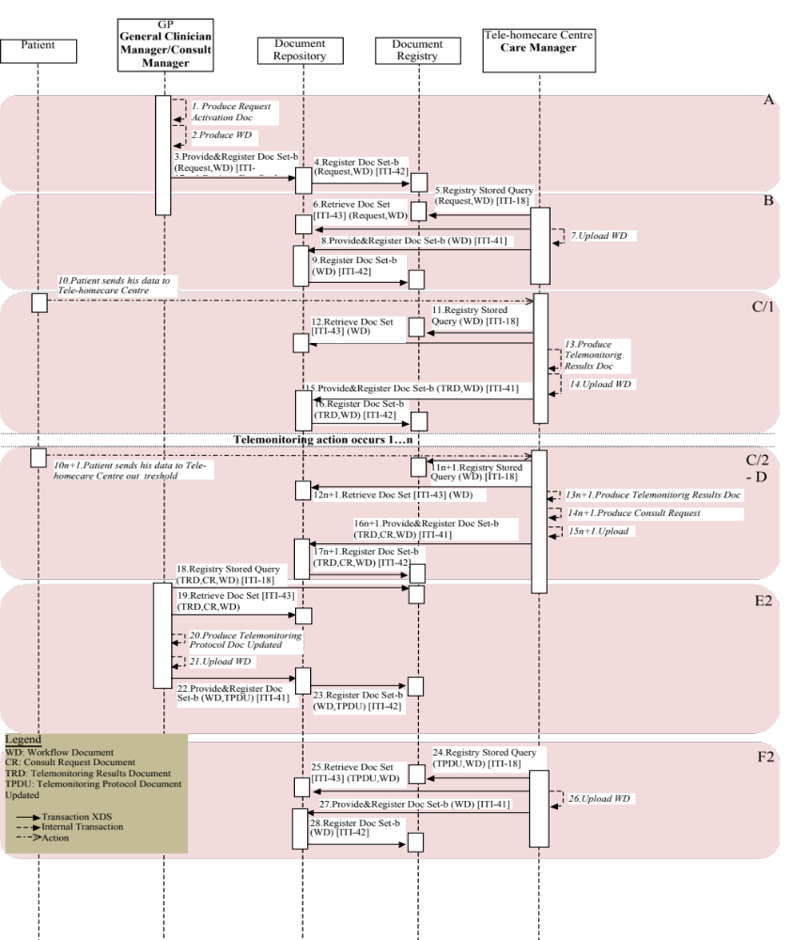
Figure 6.3-5. Basic Process Flow in Cross Enterprise TeleHomeMonitoring Workflow Definition Profile from seps A to F2
Figure 6.3-3 represents the evolution of the workflow document from the detection of an alarm situation to the decision that no action is necessary.
Figure 6.3-6 represent the sequence diagram from the begin of the telemonitoring process to the decision that noaction is necessary in case of alarm situation.

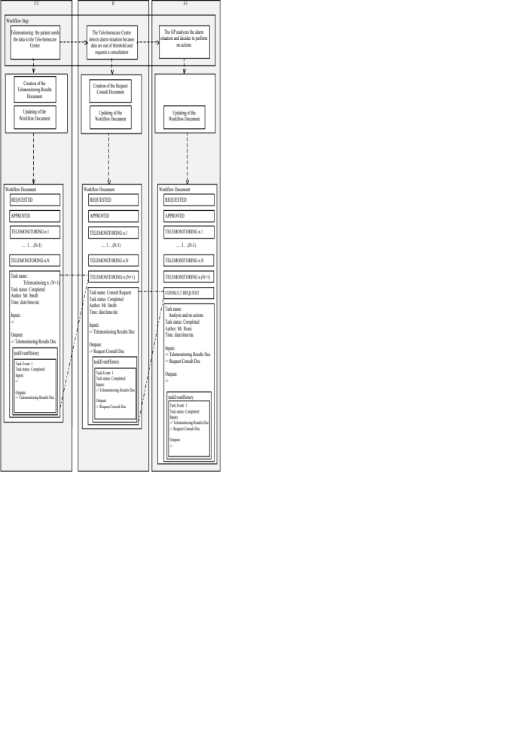
Figure 6.3-3. Management of the Workflow Document from step C/2 to step E3

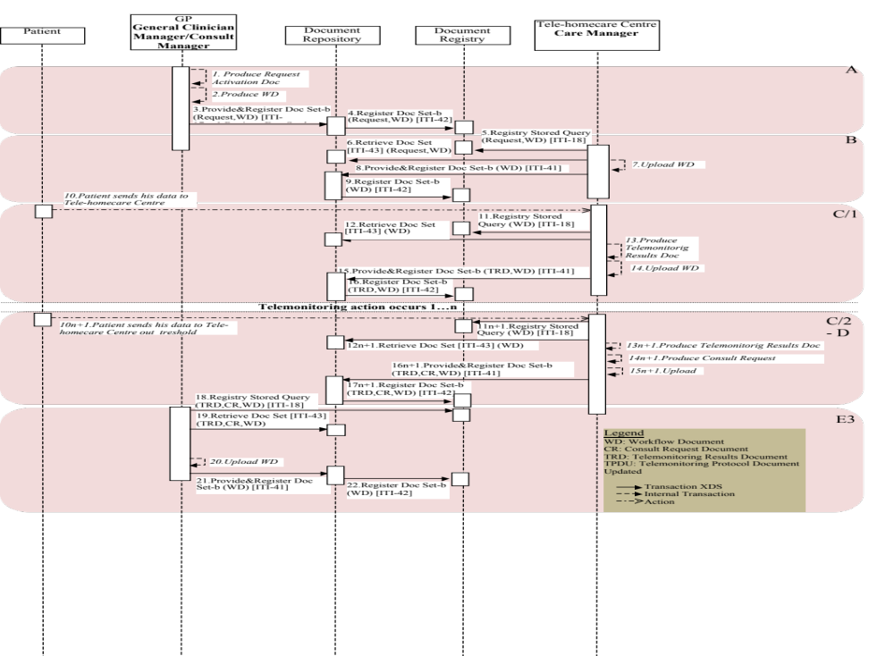
Figure 6.3-6. Basic Process Flow in Cross Enterprise TeleHomeMonitoring Workflow Definition Profile from seps A to E3

Input and output documents
The WS-HumanTask element that permits the storing of a reference to an object in input or output sections is described in IHE ITI TF-3:5.4.3.
In table 6.4-1 the kinds of documents involved in the telemonitoring process is defined. For each type of document this table allows the definition of the NAME of the document that describes the type of information conveyed and expected. The owner of a task can use these names to label the attachment, conveying this information between tasks. This name describes the function that the document performs during the evolution of the process or during the execution of the task. The same role can be played by documents characterized by different nature.

Name of Document | Content Profile | Requirement | Nature of the reference | Note
Clinical Report or Laboratory Report | XDS-SD | R | XDS document entry (in the XDS environment)  a document stored in an XDM storage memory device. or in a hyperlink (in the XDM environment) | Future additional document content profiles may be defined to include structure content.
Clinical Report or Laboratory Report | PPOC | O
Clinical Report or Laboratory Report | XD-LAB | O
Clinical Report or Laboratory Report | ECDR | O
Clinical Report or Laboratory Report | CIRC | O
Clinical Report or Laboratory Report | DRPT | O
Clinical Report or Laboratory Report | APSR | O
Request Activation Document | XDS-SD | R | XDS document entry (in the XDS environment)  a document stored in an XDM storage device | Future additional document content profiles may be defined to include structure content
Telemonitoring Result Document | PHMR | R | XDS document entry (in the XDS environment)  a document stored in an XDM storage device | PHMR (Personal Healthcare Monitoring Report) is a standard defined by HL7 to that define a CDA document that carries personal healthcare monitoring information.  Future additional document content profiles may be defined to include structure content.
Telemonitoring Result Document | XDS-SD | R
Request Consult Document | XDS-SD | R | XDS document entry (in the XDS environment)  a document stored in an XDM storage device | Future additional document content profiles may be defined to include structure content
eReferral | XDS-SD | R | XDS document entry (in the XDS environment)  a document stored in an XDM storage device | Future additional document content profiles may be defined to include structure content
Clinical Report of the Visit | XDS-SD | R | XDS document entry (in the XDS environment)  a document stored in an XDM storage device | Future additional document content profiles may be defined to include structure content
Clinical Report of the Visit | EDR | O
Clinical Report of the Visit | PPOC | O
Clinical Report of the Visit | XD-LAB | O
Clinical Report of the Visit | ECDR | O
Clinical Report of the Visit | CIRC | O
Clinical Report of the Visit | DRPT | O
Clinical Report of the Visit | APSR | O
Visit Result Document | XDS-SD | R | XDS document entry (in the XDS environment)  a document stored in an XDM storage device | Future additional document content profiles may be defined to include structure content
Telemonitoring Protocol Updated | XDS-SD | R | XDS document entry (in the XDS environment)  a document stored in an XDM storage device | Future additional document content profiles may be defined to include structure content
Table 6.4-1. Documents involved in the telemonitoring process

Appendix A- Complete example of Telemonitoring Workflow Document
In this Appendix we provide a complete example of a Workflow Document related to the telemonitoring process from the request for service activation and creation of the Workflow Document (WD), through the uploading of daily transmissions of clinical patient data, to the management of an alarm situation with no actions and then with a request of a visit.

<?xml version="1.0" encoding="UTF-8"?>
<ns3:XDW.WorkflowDocument
xmlns:ns1="urn:hl7-org:v3"
xmlns:ns2="http://docs.oasis-open.org/ns/bpel4people/ws-humantask/types/200803"
xmlns:ns3="urn:ihe:iti:2011:xdw"
xmlns:xsi="http://www.w3.org/2001/XMLSchema-instance"
xsi:schemaLocation="urn:ihe:iti:2011:xdw file:C: XDW-2011-09-13.xsd">
<ns3:id root="1.2.3.4.5"/>
<ns3:effectiveTime value="20120430131000"/>
<ns3:confidentialityCode code="1.24.3.3.3"/>
<ns3:patient>
<ns3:id root="1.3.6.1.4.1.21367.13.20.1000" extension="33333"
assigningAuthorityName="IHERED"/>
</ns3:patient>
<ns3:author>
<ns3:assignedPerson>
<ns1:name>
<ns1:family>Smith</ns1:family>
<ns1:prefix>Mr.</ns1:prefix>
</ns1:name>
</ns3:assignedPerson>
</ns3:author>
<ns3:workflowInstanceID>urn:oid:1.2.3.4</ns3:workflowInstanceID>
<ns3:workflowDocumentSequenceNumber>6</ns3:workflowDocumentSequenceNumber>
<ns3:workflowStatus>OPEN</ns3:workflowStatus>
<ns3:workflowStatusHistory>
<ns3:documentEvent>
<ns3:eventTime>2006-05-04T18:13:51.0Z</ns2:eventTime>
<ns3:eventType>create</ns2:eventType>
<ns3:taskEventIdentifier>urn:oid:1.1</ns2:taskEventIdentifier>
<ns3:author>Mr. Rossi</ns2:author >
<ns3:previousStatus></ns2:previousStatus>
<ns3:actualStatus>OPEN</ns2:actualStatus>
</ns3:documentEvent>
</ns3:workflowStatusHistory>
<ns3:workflowDefinitionReference>urn:oid:1.2.3.4.5.6.7.8.9</ns3:workflowDefinitionReference>
<ns3:TaskList>

<ns3:XDWTask>
<ns3:taskData>
<ns2:taskDetails>
<ns2:id>urn:oid:1.1.1.1.1</ns2:id>
<ns2:taskType>Requested</ns2:taskType>
<ns2:name>Activation Requested</ns2:name>
<ns2:status>COMPLETED</ns2:status>
<ns2:createdTime>2012-04-15T08:40:00.0Z</ns2:createdTime>
<ns2:lastModifiedTime>2012-04-15T08:40:00.0Z</ns2:lastModifiedTime>
<ns2:renderingMethodExists>false</ns2:renderingMethodExists>
<ns2:actualOwner>Mr. Rossi</ns2:actualOwner>
<ns2:createdBy>Mr. Rossi</ns2createdBy>
</ns2:taskDetails>
<ns2:description>Request for activation of a telehealth service</ns2:description>
<ns2:input>
<ns2:part name=”Laboratory Report”>
<reference uid=”urn:oid:1.2.3.4.1” home=”urn:oid:1.2.3”/>
</ns2:part>
</ns2:input>
<ns2:output>
<ns2:part name=”Request Activation Document”>
<reference uid=”urn:oid:1.2.3.4.2” home=”urn:oid:1.2.3”/>
</ns2:part>
</ns2:output>
</ns3:taskData>
<ns3:taskEventHistory>
<ns3:taskEvent>
<ns3:id>1</ns3:id>
<ns3:eventTime>2012-04-15T08:40:00.0Z</ns3:eventTime>
<ns3:identifier>urn:oid:1.1</ns3:identifier>
<ns3:eventType>create</ns3:eventType>
<ns3:status>COMPLETED</ns3:status>
</ns3:taskEvent>
</ns3:taskEventHistory>
</ns3:XDWTask>
<ns3:XDWTask>
<ns3:taskData>
<ns2:taskDetails>
<ns2:id>urn:oid:1.1.1.1.1</ns2:id>
<ns2:taskType>Approved</ns2:taskType>
<ns2:name>Approved Request</ns2:name>
<ns2:status>COMPLETED</ns2:status>
<ns2:createdTime>2012-04-17T10:00:00.0Z</ns2:createdTime>
<ns2:lastModifiedTime>2012-04-17T10:00:00.0Z</ns2:lastModifiedTime>
<ns2:renderingMethodExists>false</ns2:renderingMethodExists>
<ns2:actualOwner>Mr. Smith</ns2:actualOwner>
<ns2:createdBy>Mr. Smith</ns2createdBy>
</ns2:taskDetails>
<ns2:description>Request for activation of a telehealth service</ns2:description>
<ns2:input>
<ns2:part name=”Request Activation Document”>
<reference uid=”urn:oid:1.2.3.4.2” home=”urn:oid:1.2.3”/>
</ns2:part>
</ns2:input>
</ns3:taskData>
<ns3:taskEventHistory>
<ns3:taskEvent>
<ns3:id>1</ns3:id>
<ns3:eventTime>2012-04-17T10:00:00.0Z</ns3:eventTime>
<ns3:identifier>urn:oid:1.2</ns3:identifier>
<ns3:eventType>create</ns3:eventType>
<ns3:status>COMPLETED</ns3:status>
</ns3:taskEvent>
</ns3:taskEventHistory>
</ns3:XDWTask>
<ns3:XDWTask>
<ns3:taskData>
<ns2:taskDetails>
<ns2:id>urn:oid:1.2.3.4.3</ns2:id>
<ns2:taskType>Telemonitoring</ns2:taskType>
<ns2:name>Telemonitoring 1</ns2:name>
<ns2:status>COMPLETED</ns2:status>
<ns2:createdTime>2012-04-20T13:01:50.0Z</ns2:createdTime>
<ns2:lastModifiedTime>2012-04-20T13:01:50.0Z</ns2:lastModifiedTime>
<ns2:renderingMethodExists>false</ns2:renderingMethodExists>
<ns2:actualOwner>Mr. Smith</ns2:actualOwner>
<ns2:createdBy>Mr. Smith</ns2createdBy>
</ns2:taskDetails>
<ns2:description>Sending of data to the service provider</ns2:description>
<ns2:output>
<ns2:part name=”Telemonitoring Result Document”>
<reference uid=”urn:oid:1.2.3.4.2” home=”urn:oid:1.2.3”/>
</ns2:part>
</ns2:output>
</ns3:taskData>
<ns3:taskEventHistory>
<ns3:taskEvent>
<ns3:id>1</ns3:id>
<ns3:eventTime>2012-04-20T13:01:50.0Z</ns3:eventTime>
<ns3:identifier>urn:oid:1.3</ns3:identifier>
<ns3:eventType>create</ns3:eventType>
<ns3:status>COMPLETED</ns3:status>
</ns3:taskEvent>
</ns3:taskEventHistory>
</ns3:XDWTask>
<ns3:XDWTask>
<ns3:taskData>
<ns2:taskDetails>
<ns2:id>urn:oid:1.2.3.4.4</ns2:id>
<ns2:taskType>Telemonitoring</ns2:taskType>
<ns2:name>Telemonitoring 2</ns2:name>
<ns2:status>COMPLETED</ns2:status>
<ns2:createdTime>2012-04-25T13:11:00.0Z</ns2:createdTime>
<ns2:lastModifiedTime>2012-04-25T13:11:00.0Z </ns2:lastModifiedTime>
<ns2:renderingMethodExists>false</ns2:renderingMethodExists>
<ns2:actualOwner>Mr. Smith</ns2:actualOwner>
<ns2:createdBy>Mr. Smith</ns2createdBy>
</ns2:taskDetails>
<ns2:description>Sending of data to the service provider</ns2:description>
<ns2:output>
<ns2:part name=”Telemonitoring Result Document”>
<reference uid=”urn:oid:1.2.3.4.2” home=”urn:oid:1.2.3”/>
</ns2:part>
</ns2:output>
</ns3:taskData>
<ns3:taskEventHistory>
<ns3:taskEvent>
<ns3:id>1</ns3:id>
<ns3:eventTime>2012-04-25T13:11:00.0Z</ns3:eventTime>
<ns3:identifier>urn:oid:1.4</ns3:identifier>
<ns3:eventType>create</ns3:eventType>
<ns3:status>COMPLETED</ns3:status>
</ns3:taskEvent>
</ns3:taskEventHistory>
</ns3:XDWTask>
<ns3:XDWTask>
<ns3:taskData>
<ns2:taskDetails>
<ns2:id>urn:oid:1.2.3.4.5</ns2:id>
<ns2:taskType>Consult Request</ns2:taskType>
<ns2:name>Consult Request</ns2:name>
<ns2:status>COMPLETED</ns2:status>
<ns2:createdTime>2012-04-25T14:01:30.0Z</ns2:createdTime>
<ns2:lastModifiedTime>2012-04-25T14:01:30.0Z</ns2:lastModifiedTime>
<ns2:renderingMethodExists>false</ns2:renderingMethodExists>
<ns2:actualOwner>Mr. Smith</ns2:actualOwner>
<ns2:createdBy>Mr. Smith</ns2createdBy>
</ns2:taskDetails>
<ns2:description>Generation of an alarm because data are out of the thershold </ns2:description>
<ns2:input>
<ns2:part name=”Telemonitoring Result Document”>
<reference uid=”urn:oid:1.2.3.4.2” home=”urn:oid:1.2.3”/>
</ns2:part>
</ns2:input>
<ns2:output>
<ns2:part name=”Request Consult Document”>
<reference uid=”urn:oid:1.2.3.4.2” home=”urn:oid:1.2.3”/>
</ns2:part>
</ns2:output>
</ns3:taskData>
<ns3:taskEventHistory>
<ns3:taskEvent>
<ns3:id>1</ns3:id>
<ns3:eventTime>2012-04-25T14:01:30.0Z </ns3:eventTime>
<ns3:identifier>urn:oid:1.5</ns3:identifier>
<ns3:eventType>create</ns3:eventType>
<ns3:status>COMPLETED</ns3:status>
</ns3:taskEvent>
</ns3:taskEventHistory>
<ns3:XDWTask>
<ns3:XDWTask>
<ns3:taskData>
<ns2:taskDetails>
<ns2:id>urn:oid:1.2.3.4.6</ns2:id>
<ns2:taskType>Analysis and no Actions</ns2:taskType>
<ns2:name> Analysis and no Actions</ns2:name>
<ns2:status>COMPLETED</ns2:status>
<ns2:createdTime>2012-04-27T17:56:07.0Z</ns2:createdTime>
<ns2:lastModifiedTime>2012-04-27T17:56:07.0Z</ns2:lastModifiedTime>
<ns2:renderingMethodExists>false</ns2:renderingMethodExists>
<ns2:actualOwner>Mr. Rossi</ns2:actualOwner>
<ns2:createdBy>Mr. Rossi</ns2createdBy>
</ns2:taskDetails>
<ns2:description>Analysis of the Telemonitoring Results Document and no actions are necessary</ns2:description>
<ns2:input>
<ns2:part name=”Telemonitoring Result Document”>
<reference uid=”urn:oid:1.2.3.4.2” home=”urn:oid:1.2.3”/>
</ns2:part>
<ns2:part name=”Request Consult Document”>
<reference uid=”urn:oid:1.2.3.4.2” home=”urn:oid:1.2.3”/>
</ns2:part>
</ns2:input>
</ns3:taskData>
<ns3:taskEventHistory>
<ns3:taskEvent>
<ns3:id>1</ns3:id>
<ns3:eventTime>2012-04-27T17:56:07.0Z</ns3:eventTime>
<ns3:identifier>urn:oid:1.6</ns3:identifier>
<ns3:eventType>create</ns3:eventType>
<ns3:status>COMPLETED</ns3:status>
</ns3:taskEvent>
</ns3:taskEventHistory>
</ns3:XDWTask>

<ns3:XDWTask>
<ns3:taskData>
<ns2:taskDetails>
<ns2:id>urn:oid:1.2.3.4.7</ns2:id>
<ns2:taskType>Telemonitoring</ns2:taskType>
<ns2:name>Telemonitoring 3</ns2:name>
<ns2:status>COMPLETED</ns2:status>
<ns2:createdTime>2012-04-30T13:10:00.0Z</ns2:createdTime>
<ns2:lastModifiedTime>2012-04-30T13:10:00.0Z</ns2:lastModifiedTime>
<ns2:renderingMethodExists>false</ns2:renderingMethodExists>
<ns2:actualOwner>Mr. Smith</ns2:actualOwner>
<ns2:createdBy>Mr. Smith</ns2createdBy>
</ns2:taskDetails>
<ns2:description>Sending of data to the service provider</ns2:description>
<ns2:output>
<ns2:part name=”Telemonitoring Result Document”>
<reference uid=”urn:oid:1.2.3.4.2” home=”urn:oid:1.2.3”/>
</ns2:part>
</ns2:output>
</ns3:taskData>
<ns3:taskEventHistory>
<ns3:taskEvent>
<ns3:id>1</ns3:id>
<ns3:eventTime>2012-04-30T13:10:00.0Z</ns3:eventTime>
<ns3:identifier>urn:oid:1.7</ns3:identifier>
<ns3:eventType>create</ns3:eventType>
<ns3:status>COMPLETED</ns3:status>
</ns3:taskEvent>
</ns3:taskEventHistory>
</ns3:XDWTask>

<ns3:XDWTask>
<ns3:taskData>
<ns2:taskDetails>
<ns2:id>urn:oid:1.2.3.4.8</ns2:id>
<ns2:taskType>Consult Request</ns2:taskType>
<ns2:name>Consult Request</ns2:name>
<ns2:status>COMPLETED</ns2:status>
<ns2:createdTime>2012-04-30T11:00:00.0Z</ns2:createdTime>
<ns2:lastModifiedTime>2012-04-30T11:00:00.0Z</ns2:lastModifiedTime>
<ns2:renderingMethodExists>false</ns2:renderingMethodExists>
<ns2:actualOwner>Mr. Smith</ns2:actualOwner>
<ns2:createdBy>Mr. Smith</ns2createdBy>
</ns2:taskDetails>
<ns2:description>Generation of an alarm because data are out of the thershold </ns2:description>
<ns2:input>
<ns2:part name=”Telemonitoring Result Document”>
<reference uid=”urn:oid:1.2.3.4.2” home=”urn:oid:1.2.3”/>
</ns2:part>
</ns2:input>
<ns2:output>
<ns2:part name=”Request Consult Document”>
<reference uid=”urn:oid:1.2.3.4.2” home=”urn:oid:1.2.3”/>
</ns2:part>
</ns2:output>
</ns3:taskData>
<ns3:taskEventHistory>
<ns3:taskEvent>
<ns3:id>1</ns3:id>
<ns3:eventTime>2012-04-30T11:00:00.0Z<ns3:eventTime>
<ns3:identifier>urn:oid:1.8</ns3:identifier>
<ns3:eventType>create</ns3:eventType>
<ns3:status>COMPLETED</ns3:status>
</ns3:taskEvent>
</ns3:taskEventHistory>
<ns3:XDWTask>

<ns3:XDWTask>
<ns3:taskData>
<ns2:taskDetails>
<ns2:id>urn:oid:1.2.3.4.9</ns2:id>
<ns2:taskType>Analysis and Request Visit</ns2:taskType>
<ns2:name>Analysis and Request Visit</ns2:name>
<ns2:status>COMPLETED</ns2:status>
<ns2:createdTime>2012-05-3T08:30:00.0Z</ns2:createdTime>
<ns2:lastModifiedTime>2012-05-3T08:30:00.0Z</ns2:lastModifiedTime>
<ns2:renderingMethodExists>false</ns2:renderingMethodExists>
<ns2:actualOwner>Mr. Rossi</ns2:actualOwner>
<ns2:createdBy>Mr. Rossi</ns2createdBy>
</ns2:taskDetails>
<ns2:description>Analysis of the Telemonitoring Results Document and request of a specialistic consultation</ns2:description>
<ns2:input>
<ns2:part name=”Telemonitoring Result Document”>
<reference uid=”urn:oid:1.2.3.4.2” home=”urn:oid:1.2.3”/>
</ns2:part>
<ns2:part name=”Request Consult Document”>
<reference uid=”urn:oid:1.2.3.4.2” home=”urn:oid:1.2.3”/>
</ns2:part>
</ns2:input>
<ns2:output>
<ns2:part name=”eReferral Document”>
<reference uid=”urn:oid:1.2.3.4.2” home=”urn:oid:1.2.3”/>
</ns2:part>
<ns2:part name=”XDSFolder.uniqueId”>
<reference uid=”urn:oid:1.2.3.4.2” home=”urn:oid:1.2.3”/>
</ns2:part>
</ns2:output>
</ns3:taskData>
<ns3:taskEventHistory>
<ns3:taskEvent>
<ns3:id>1</ns3:id>
<ns3:eventTime>2012-05-3T08:30:00.0Z</ns3:eventTime>
<ns3:identifier>urn:oid:1.9</ns3:identifier>
<ns3:eventType>create</ns3:eventType>
<ns3:status>COMPLETED</ns3:status>
</ns3:taskEvent>
</ns3:taskEventHistory>
</ns3:XDWTask>
<ns3:XDWTask>
<ns3:taskData>
<ns2:taskDetails>
<ns2:id>urn:oid:1.2.3.4.10</ns2:id>
<ns2:taskType>Visit Result</ns2:taskType>
<ns2:name>Visit Result</ns2:name>
<ns2:status>COMPLETED</ns2:status>
<ns2:createdTime>2012-05-7T08:30:00.0Z</ns2:createdTime>
<ns2:lastModifiedTime>2012-05-7T08:30:00.0Z</ns2:lastModifiedTime>
<ns2:renderingMethodExists>false</ns2:renderingMethodExists>
<ns2:actualOwner>Mr. Rossi</ns2:actualOwner>
<ns2:createdBy>Mr. Rossi</ns2createdBy>
</ns2:taskDetails>
<ns2:description>Analysis of the Results of the eReferral process requested </ns2:description>
<ns2:input>
<ns2:part name=”Clinical Report”>
<reference uid=”urn:oid:1.2.3.4.2” home=”urn:oid:1.2.3”/>
</ns2:part>
<ns2:part name=”XDSFolder.uniqueId”>
<reference uid=”urn:oid:1.2.3.4.2” home=”urn:oid:1.2.3”/>
</ns2:part>
</ns2:input>
<ns2:output>
<ns2:part name=”Visit Result Document”>
<reference uid=”urn:oid:1.2.3.4.2” home=”urn:oid:1.2.3”/>
</ns2:part>
</ns2:output>
</ns3:taskData>
<ns3:taskEventHistory>
<ns3:taskEvent>
<ns3:id>1</ns3:id>
<ns3:eventTime>2012-05-7T08:30:00.0Z</ns3:eventTime>
<ns3:identifier>urn:oid:1.10</ns3:identifier>
<ns3:eventType>create</ns3:eventType>
<ns3:status>COMPLETED</ns3:status>
</ns3:taskEvent>
</ns3:taskEventHistory>
</ns3:XDWTask>
<ns3:XDWTask>
<ns3:taskData>
<ns2:taskDetails>
<ns2:id>urn:oid:1.2.3.4.11</ns2:id>
<ns2:taskType>Telemonitoring</ns2:taskType>
<ns2:name>Telemonitoring 4</ns2:name>
<ns2:status>FAILED</ns2:status>
<ns2:createdTime>2012-05-8T09:36:00.0Z</ns2:createdTime>
<ns2:lastModifiedTime>2012-05-8T09:36:00.0Z</ns2:lastModifiedTime>
<ns2:renderingMethodExists>false</ns2:renderingMethodExists>
<ns2:actualOwner>Mr. Smith</ns2:actualOwner>
<ns2:createdBy>Mr. Smith</ns2createdBy>
</ns2:taskDetails>
<ns2:description>Sending of data to the service provider</ns2:description>
<ns2:output>
<ns2:part name=”Telemonitoring Result Document”>
<reference uid=”urn:oid:1.2.3.4.2” home=”urn:oid:1.2.3”/>
</ns2:part>
</ns2:output>
</ns3:taskData>
<ns3:taskEventHistory>
<ns3:taskEvent>
<ns3:id>1</ns3:id>
<ns3:eventTime>2012-05-8T09:36:00.0Z</ns3:eventTime>
<ns3:identifier>urn:oid:1.11</ns3:identifier>
<ns3:eventType>fail</ns3:eventType>
<ns3:status>FAILED</ns3:status>
</ns3:taskEvent>
</ns3:taskEventHistory>
</ns3:XDWTask>
</ns3:TaskList>
</ns3:XDW.WorkflowDocument>

The first three documents can be located on the IHE Website at http://www.ihe.net/Technical_Framework/index.cfm#IT. The remaining documents can be obtained from their respective publishers.

